**Abstract**

Through model design and computer simulation calculations, this study explores the impacts of the blockchain electronic invoice system and the paper invoice system on economic efficiency and social fairness under different audit success rates. The research findings indicate that under specific conditions, the advanced system can promote economic benefits and social fairness.

**Keywords:** blockchain; value-added tax; simulation

Chapter Contents

Introduction 1

Literature Review 11

Methodology 22

Data Results and Analysis 24

Conclusion 48

Bibliography 49

**List of Tables and Figures**

Table 1 20

Table 2 27

Figure 1 3

Figure 2 4

Figure 3 5

Figure 4 6

Figure 5 7

Figure 6 8

Figure 7 9

Figure 8 13

Figure 9 14

Figure 10 27

Figure 11 27

Figure 12 28

Figure 13 30

Figure 14 31

Figure 15 32

Figure 16 33

Figure 17 34

Figure 18 34

Figure 19 35

Figure 20 36

Figure 21 38

Figure 22 40

Figure 23 43

Figure 24 45

**Introduction**

For a long time, various countries and regions have experienced tax evasion to different degrees. Tax evaders save costs through evasion while enjoying public resources built with fiscal expenditures from tax authorities, which are funded by those who actually pay taxes. This is unfair to law-abiding individuals and companies. Reducing or even eliminating tax evasion has always been a priority for governments and tax authorities worldwide. A lower tax evasion rate typically means higher tax revenues for tax authorities, which in turn means more fiscal funds available for government allocation. Increased fiscal funds enable better construction of social public resources, promoting social and economic development and generating more tax revenue in a positive cycle. This not only enhances social fairness but also improves economic efficiency.

However, reducing the tax evasion rate requires tax authorities to improve their tax audit success rate, which often incurs higher costs. Increased costs mean fewer funds available for public spending, potentially reducing economic mobility and social fairness unless the higher costs lead to a sufficiently high audit success rate. Only then can the negative impacts of tax evasion be more effectively mitigated, enhancing economic efficiency and social fairness. This paper explores under what cost and audit success rate conditions the tax system can bring positive impacts to the economy.

**1．Basic introduction to circulation taxes**

Generally speaking, whether it is income tax, value-added tax (VAT), or other types of taxes, the main basis for calculating these taxes is invoices. This is because invoices are the original vouchers for accounting and also the most fundamental legal basis for each transaction. The information recorded on an invoice generally includes goods, amount, buyer, seller, date, signature, etc. From a company's financial statements to the tax revenue of the tax authority, invoices are the most basic and fundamental element. Therefore, most of the methods of tax evasion start with invoices. Generally speaking, there are three categories of tax evasion methods. One category is issuing fewer invoices or not issuing invoices at all. Another category is invoice forgery, and the last category is issuing false invoices.

Value-added tax and corporate income tax are the two types of taxes most closely related to invoices. Since value-added tax was proposed by Maurice Lauré in 1954, it has been used by various countries due to its innovation, fairness, and high efficiency. Different from traditional sales tax, value-added tax is levied on the value-added part of goods or services at each production and distribution link, instead of being collected as a lump sum at the final sales stage. [1] Corporate income tax, on the other hand, is levied on the profits of enterprises, and the main basis for tax calculation is also invoices. Taking Chinese invoices as an example, they are mainly divided into special invoices and ordinary invoices. The former can be used to deduct input tax for value-added tax, while the latter cannot. Both can serve as the basis for calculating income tax.

Value-added tax and income tax have always been the main components of China's tax revenue, and China's tax revenue is the main component of China's fiscal revenue. In 2024, China's general public budget revenue was $2,197.02 billion, and China's tax revenue was $1,749.72 billion, accounting for 79.64%. Domestic value-added tax (excluding imports) was $666.72 billion, accounting for 38.10% of the tax revenue, and corporate income tax was $408.87 billion, accounting for 23.37% of the tax revenue. [2] These two are the two types of taxes that account for the largest proportion of tax revenue, and they are also the two types of taxes with the highest requirements for the authenticity of invoices. At the same time, they are also the two most common types of taxes targeted by tax evaders.

Normally, when a supplier sells goods to a retailer, it will issue an invoice to the latter. The value-added tax amount on the invoice is the output tax for the supplier and the input tax for the retailer. When the retailer sells goods to consumers, it also needs to issue an invoice. At this time, the tax amount recorded on the invoice is the output tax for the retailer. By subtracting the input tax from the output tax, the value-added tax amount can be obtained, which is the tax amount to be paid to the tax authority. The following is an illustration of the calculation methods for value-added tax and income tax.

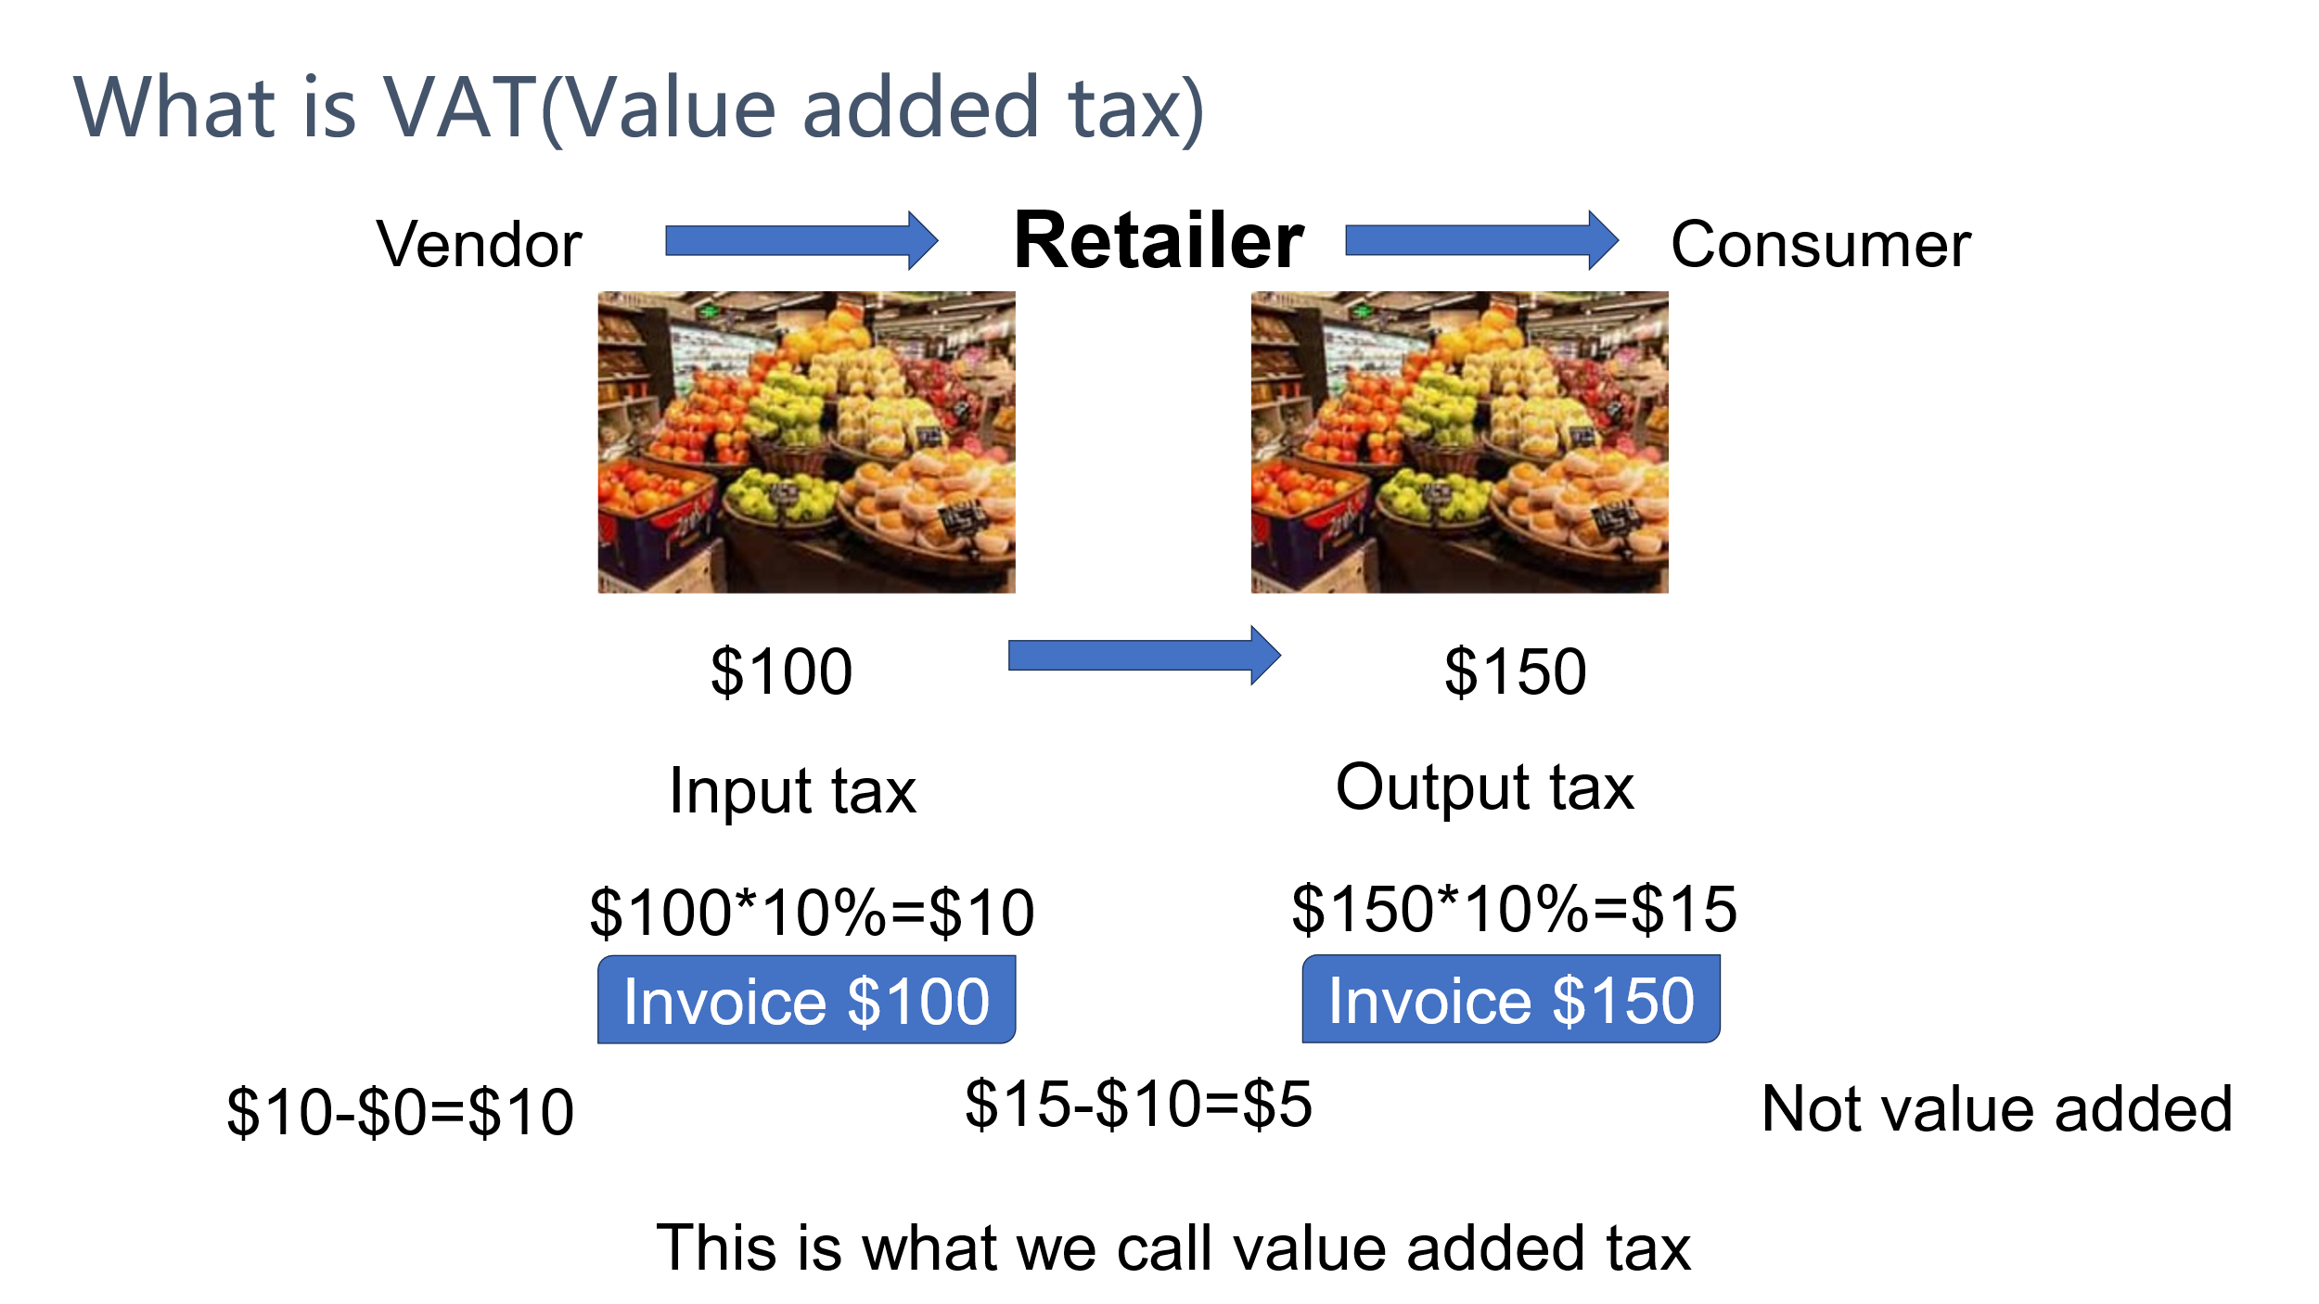

Figure 1

Suppose the value-added tax (VAT) rate is 10%. The retailer purchases fruits worth $100 from the supplier and then sells them for $150. In this case, the retailer's input tax is $100 * 10% = $10, the output tax is $150 * 10% = $15, and the value-added tax is $15 - $10 = $5. Alternatively, the value-added amount from the sale of the goods is $150 - $100 = $50, and the value-added tax is $50 * 10% = $5.

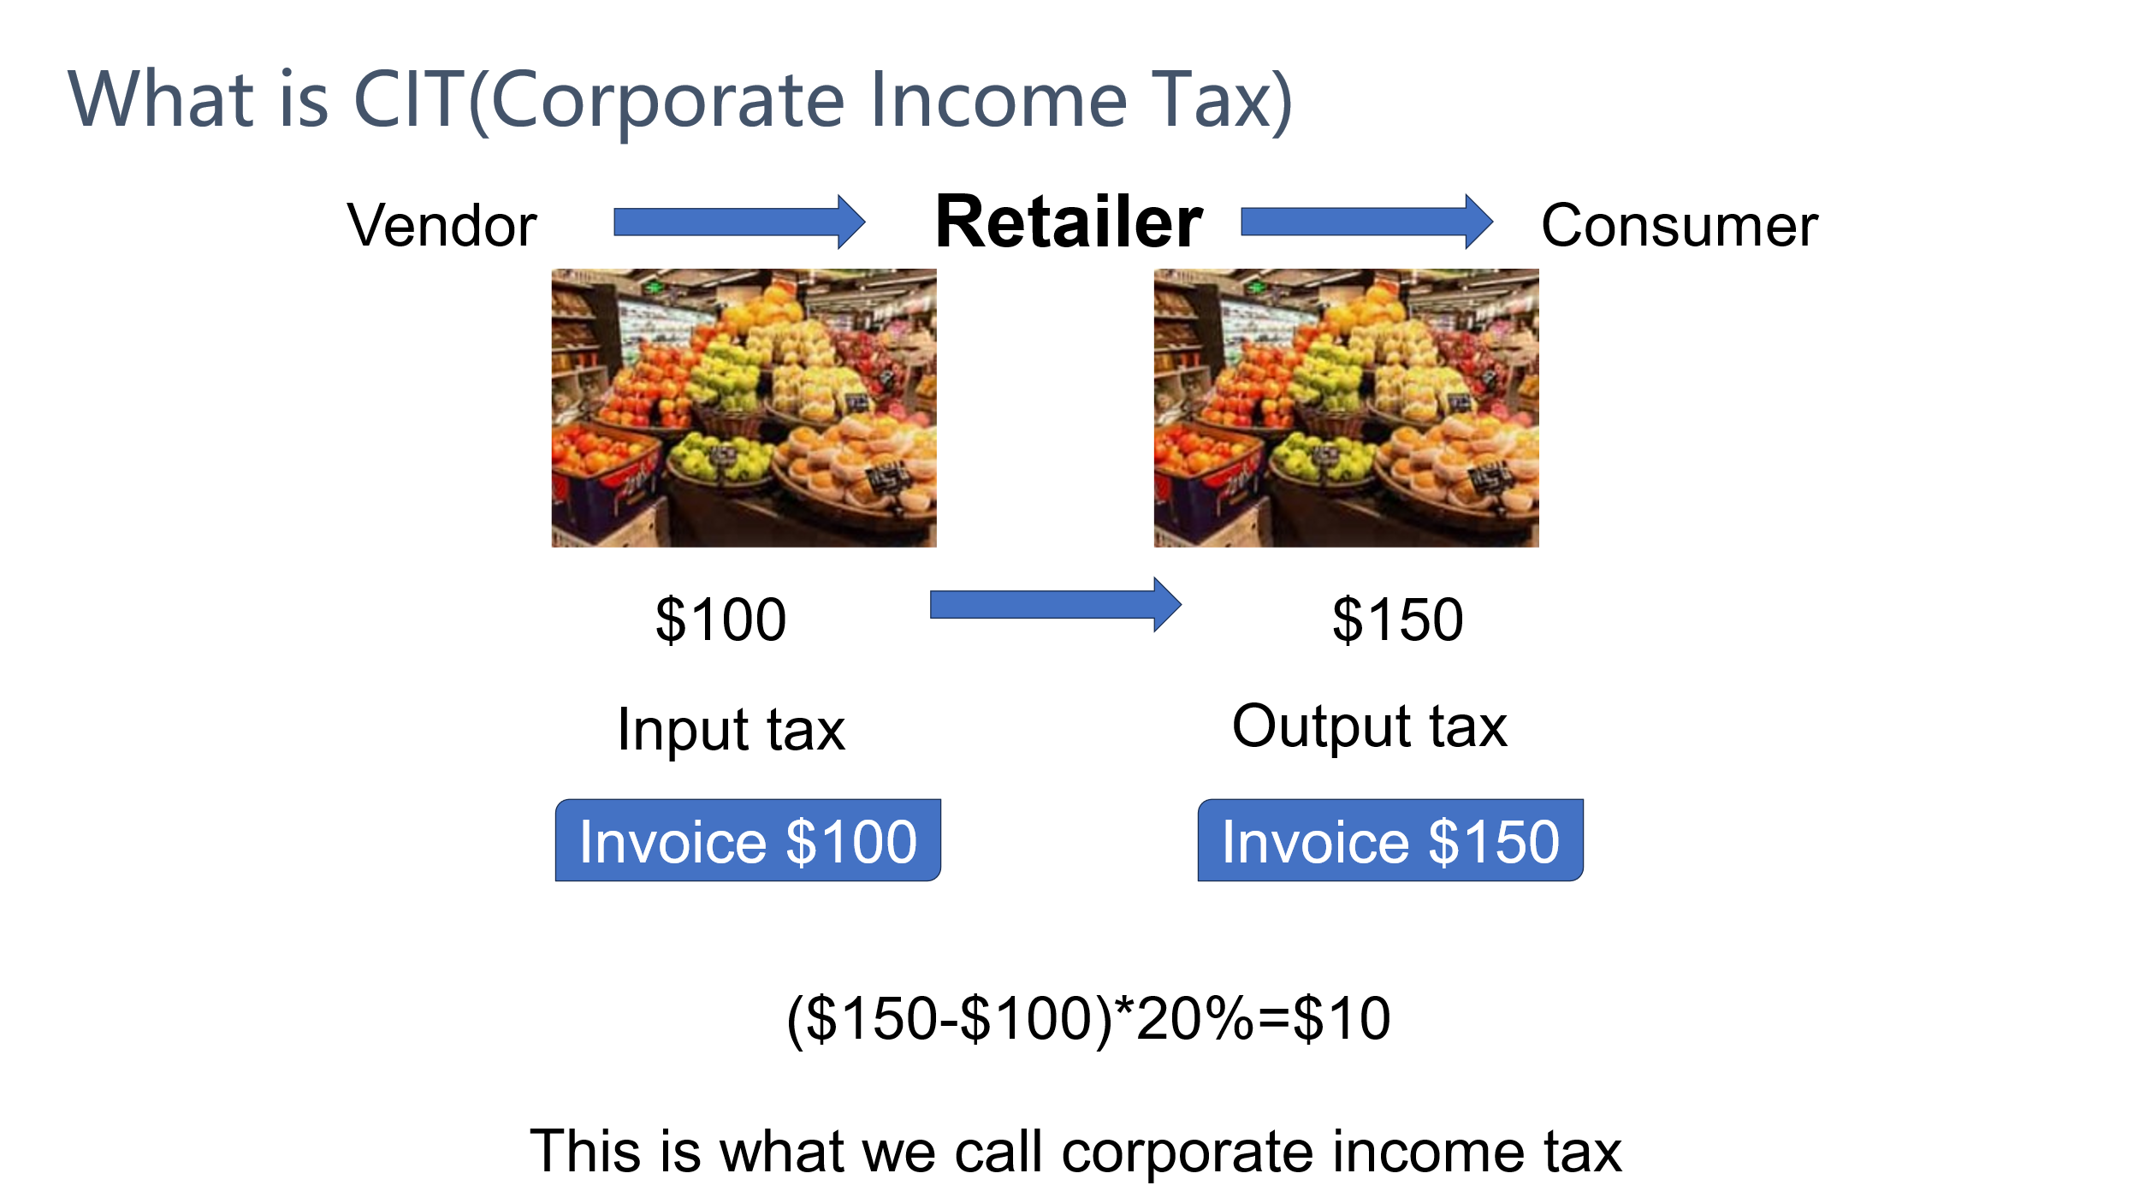

Figure 2

Suppose the corporate income tax rate is 20%. The retailer purchases fruits worth $100 from the supplier and then sells them for $150. Then the retailer's profit is $150 - $100 = $50, and the corporate income tax is $50 * 20% = $10.

**2.** **Introduction to the Taxation System**

Generally speaking, there are two types of taxation systems, both of which have the invoice system as their core. After enterprises or individuals issue invoices through the system, the tax authority obtains the invoice information. One type is the paper invoice system, and the other is the electronic invoice system. There are two categories within the electronic invoice system. One creates invoices through a centralized server and records the invoice data of various enterprises and individuals. The other uses blockchain technology to create and record invoice information in a decentralized manner.

Blockchain is a decentralized distributed ledger that records transaction information in a secure, transparent, and tamper-proof way. Through encryption algorithms and consensus mechanisms, blockchain ensures that data is synchronized and consistent among network participants without relying on a single control source. The invoicing system based on blockchain technology makes each electronic invoice unique and highly anti-counterfeiting. In contrast, paper invoices are encrypted through hardware encryption technology and anti-counterfeiting coatings similar to those on banknotes to ensure the uniqueness and non-tamperability of the invoices.

Taking China as an example again, as early as 2018, China utilized the characteristics of blockchain to build a tax invoicing system. In August 2018, the Shenzhen Guomao Rotating Restaurant issued the first blockchain electronic invoice in the country. As of October 27, there were more than 7,500 enterprises in Shenzhen registered to use blockchain electronic invoices, with a total of over 9.75 million invoices issued, involving an amount of $6.93 billion, covering multiple people's livelihood fields such as catering, retail, transportation, and accommodation. [3]

So how does the tax authority obtain tax revenue from the trade between retailers and suppliers? First, let's introduce value-added tax. Taking Figure 3 as an example, first, after the supplier issues an invoice to the retailer, the tax authority will obtain the supplier's invoice information after a certain period of time, and thus has a tax claim against the supplier. After the supplier pays $10 to the tax authority, the tax authority will clear this claim. After the retailer receives the invoice issued by the supplier, it has an input tax of $10, and this input tax can be used to offset the output tax. After the retailer sells the goods and issues an invoice, the tax authority has a claim of $15 against the retailer, that is, the retailer's output tax is $15. However, since the retailer has an input tax of $10, in fact, the retailer only needs to pay a value-added tax amount of $5.

Income tax does not require the deduction calculation of the tax system, but it requires accounting firms to verify the authenticity of the invoices and issue audit reports. However, the verification method of accounting firms is manual verification, which is less accurate than the verification of the tax system. Therefore, it is easier for enterprises or individuals to evade income tax than value-added tax. For example, they can print a few more invoices manually, or participate in tax evasion and fraud by bribing auditors. 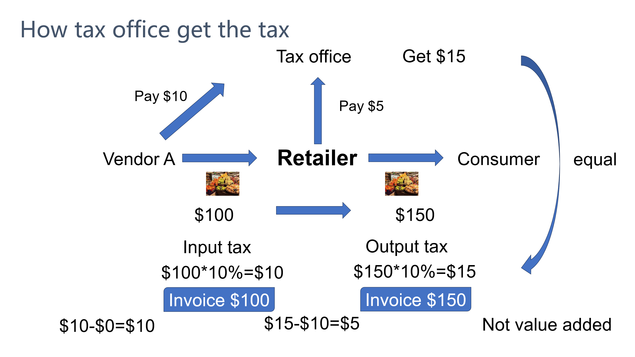

Figure 3

**3. Introduction to Common Tax Evasion Methods**

If there are only two stages in the circulation of a commodity, namely the supplier and the retailer, then the stage of tax evasion is either on the part of the supplier or the retailer. As the source, the supplier can only evade taxes during the sales stage, that is, by underreporting or reporting a lower sales amount, so as to pay less tax or no tax at all.

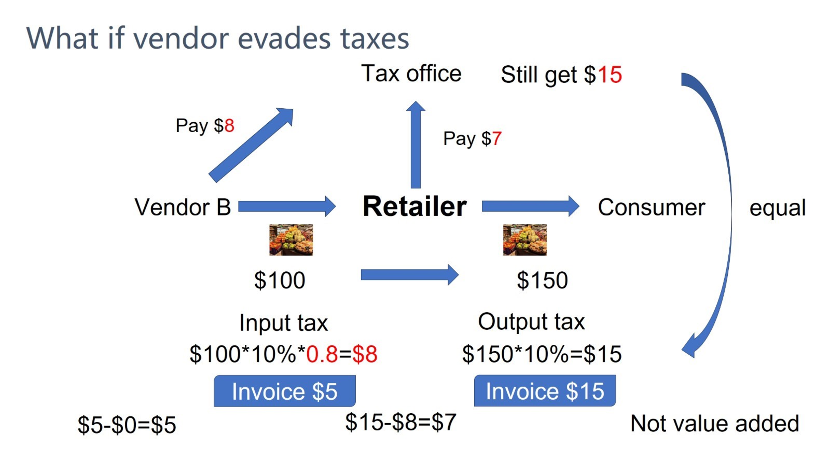

Figure 4

Suppose the supplier only reports 80% of the actual sales amount. As shown in Figure 4, then the tax that he finally needs to pay to the tax authority is $8 instead of $10. Correspondingly, the retailer can only obtain an input tax of $8, while his output tax is $15. Then the tax that he finally needs to pay to the tax authority is $15 - $8 = $7. In the end, the tax received by the tax authority is the $8 from the supplier plus the $7 from the retailer, which is still $15 in total. That is to say, if the supplier evades taxes, the revenue of the tax authority will not be affected. On the contrary, the tax burden of the retailer will be increased instead. Therefore, the tax authority actually will not pay too much attention to the tax evasion behavior of upstream enterprises.

Let's look at the situation of tax evasion by the retailer. The retailer can evade taxes in two stages. One is the sales stage, where he can evade taxes by underreporting the sales amount. The other is the procurement stage, where he can evade taxes by purchasing false invoices to fraudulently inflate the procurement amount.

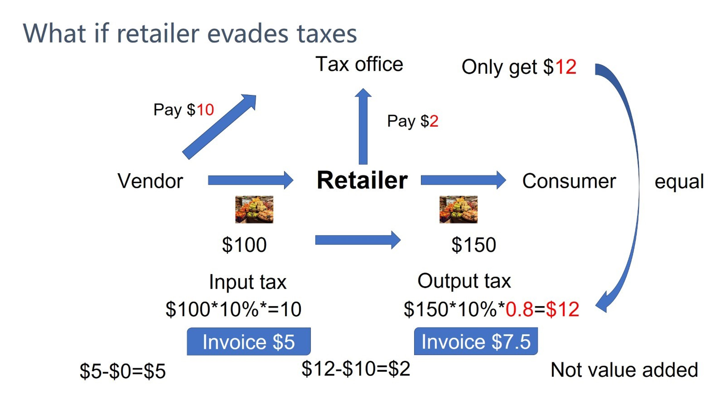

Figure 5

Let's first talk about the first type, which is tax evasion in the sales stage. As the terminal link in the commodity circulation, the invoice issued by the retailer during sales cannot be used as input tax for deduction by consumers in the next stage, because most consumers in the last stage are individuals. Therefore, tax evasion by the retailer in the sales stage is quite different from that by the supplier. As can be seen from Figure 5, after the retailer reports 80% of the actual sales amount, he only needs to pay the tax authority $15 * 80% - 10 = $2 in the end. Eventually, the tax authority can only receive $10 from the supplier plus $2 from the retailer, that is, it can only receive $12 in total. This is $3 less than the $15 it can receive when the retailer does not evade taxes. Therefore, for the tax authority, the inspection of tax evasion in the sales stage of the retailer is much more important than that of the supplier.

There is another type, which is tax evasion by the retailer in the procurement stage, generally by purchasing false value-added tax invoices. There will be some criminals in the market. They will establish some shell companies, then fabricate large sales records and issue a large number of invoices within a short period of time. Finally, they will sell these invoices to retailers at a low price, and then escape legal sanctions by applying for bankruptcy or emigrating abroad and other means.

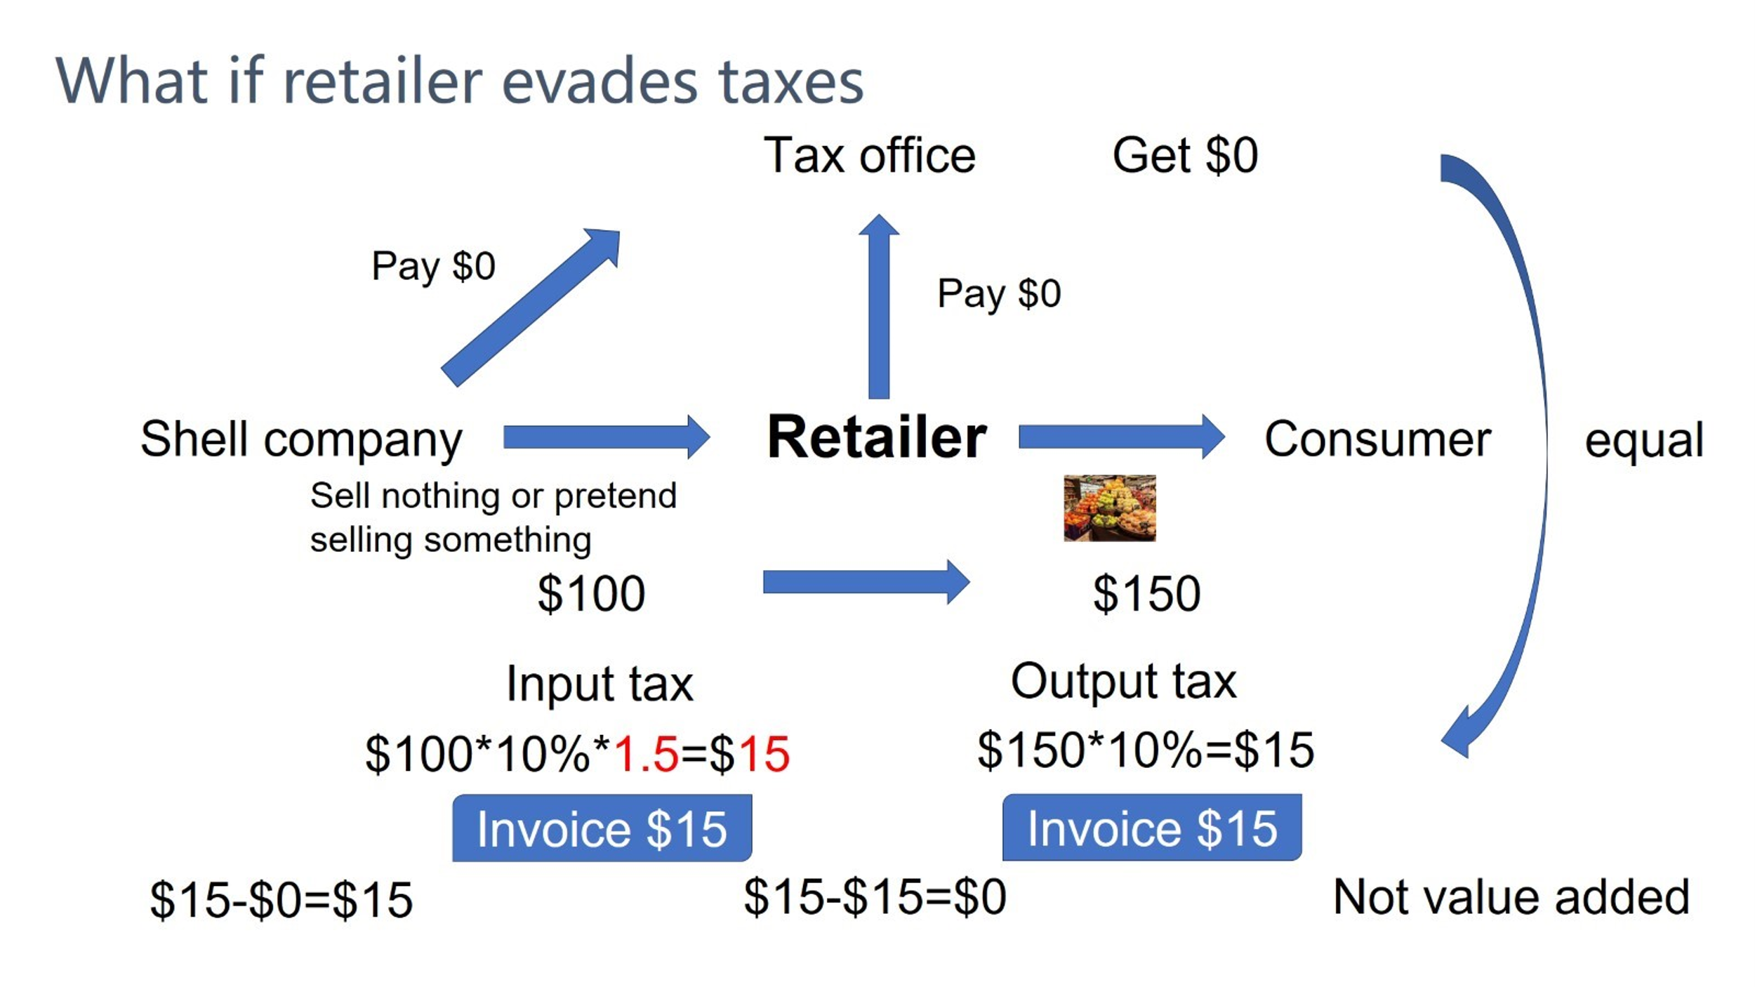

Figure 6

As shown in Figure 6, the retailer will purchase an additional 0.5 times the amount of invoices from the shell company. In this way, the retailer will have an input tax of $15, and the retailer's output tax is also only $15. Finally, the retailer does not need to pay any tax to the tax authority.

**4.** **Introduction to the Audit of the Blockchain Invoice System**

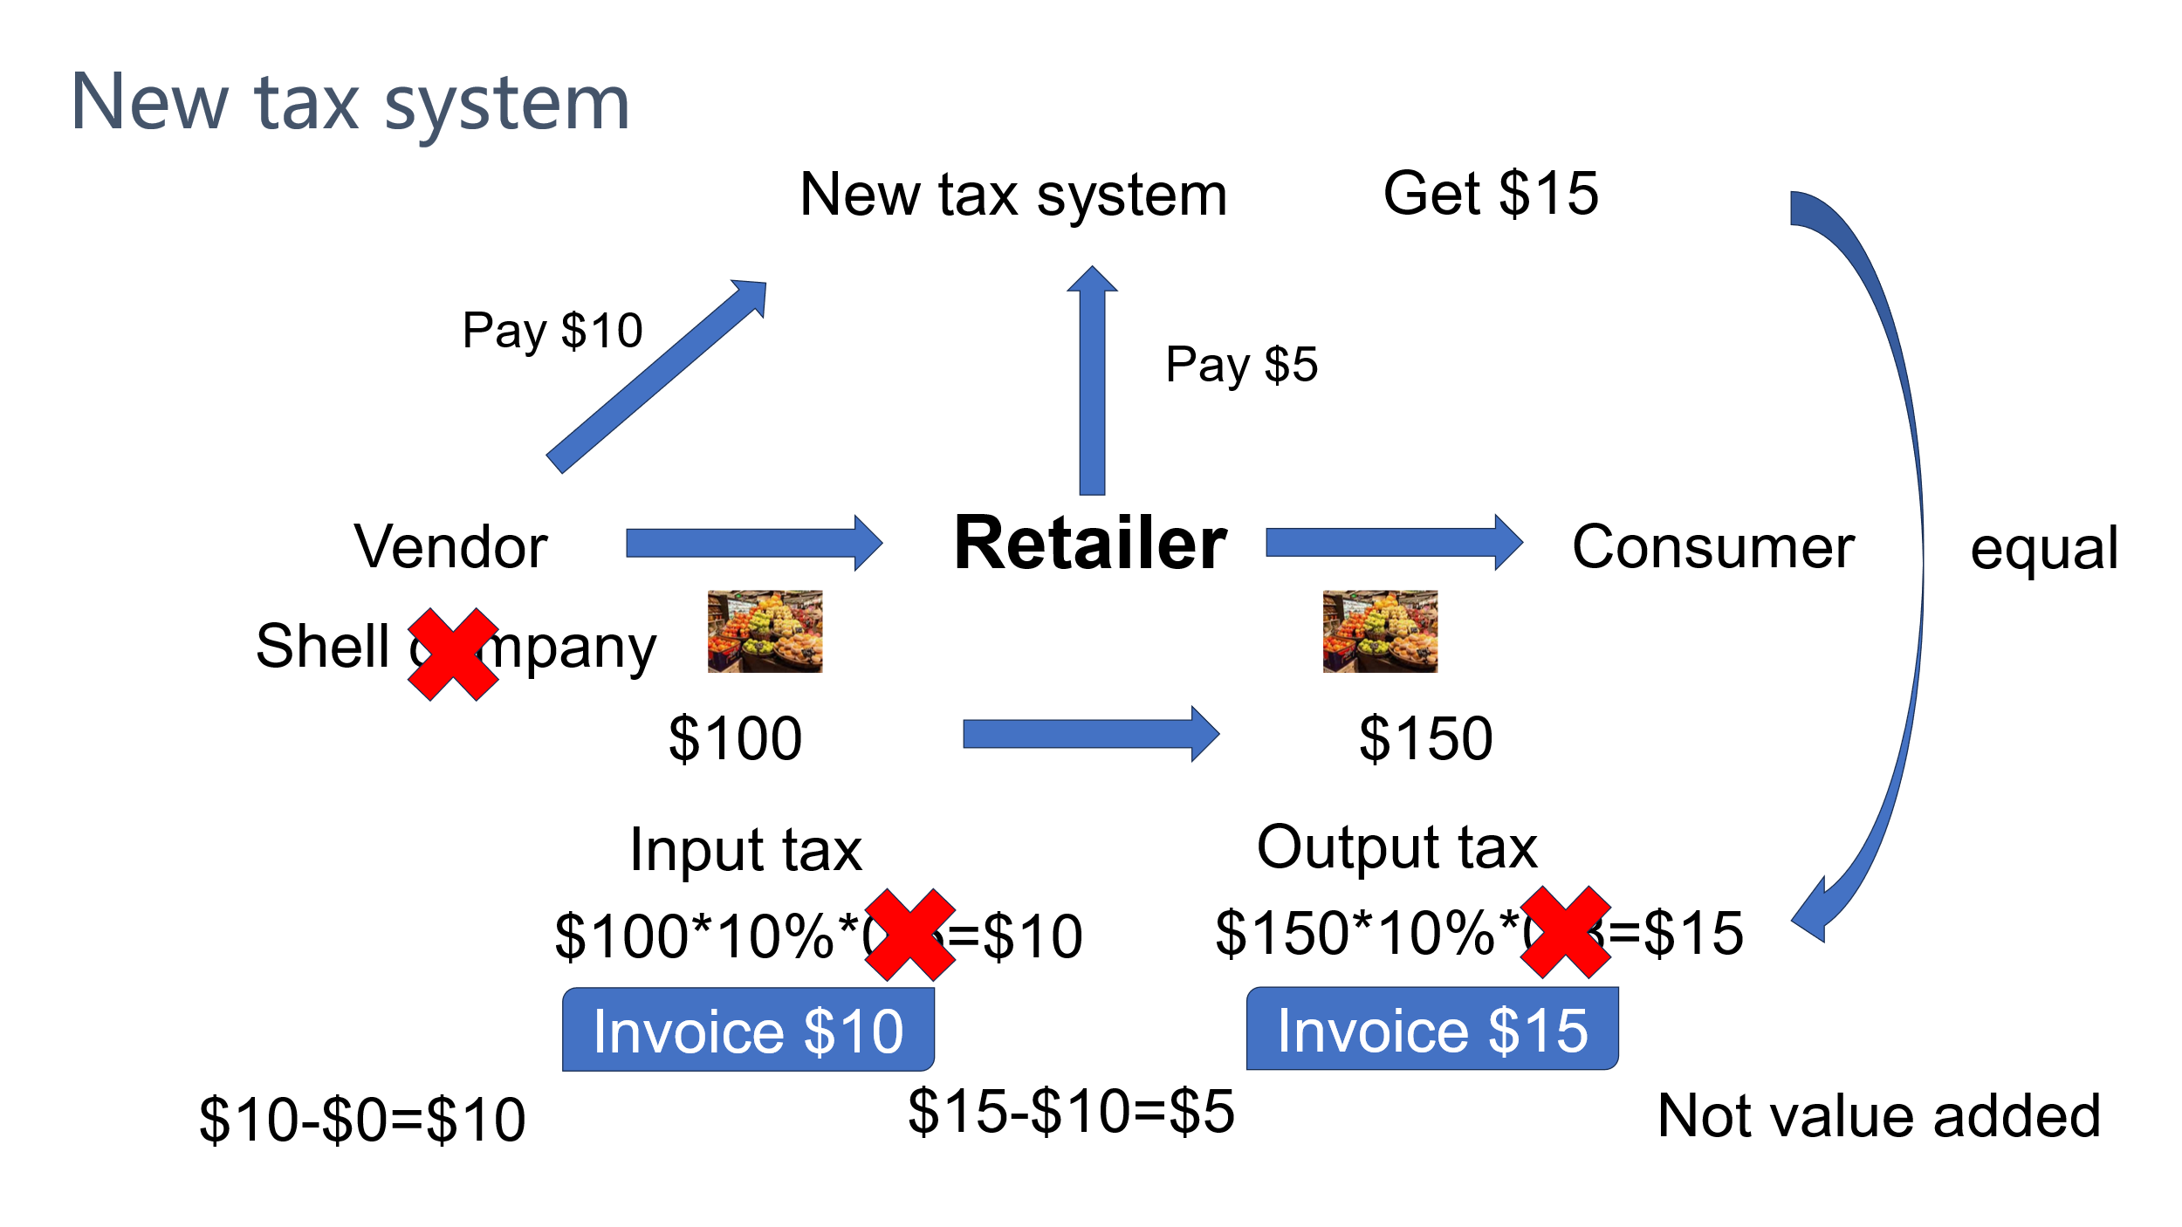

Figure 7

Compared with paper invoices, blockchain electronic invoices have the characteristic of real-time acquisition of invoicing data. This has put an end to the behavior of shell companies issuing a large number of invoices within a short period of time and then evading legal sanctions. Although shell companies can still issue false small-amount invoices, if a shell company fails to file a tax return and pay taxes on time within the month, the tax authority will conduct on-site inspections. In this way, criminals can only choose between paying taxes on time and obtaining a small reward. If the shell company chooses the latter, although the tax authority will suffer losses, they will be much smaller than before.

The next chapter will introduce the technical principles of the blockchain electronic invoice system for enhancing the audit success rate to reduce tax evasion. Through blockchain technology and electronic information technology, the blockchain electronic invoice system can not only reduce the behavior of shell companies issuing a large number of false invoices in a short period of time, but also the anti-counterfeiting property of blockchain technology can reduce tax evasion behaviors such as reprinting invoices and underreporting sales amounts.

**Literature Review**

Currently, there is relatively little research on the combination of blockchain technology and electronic invoice systems. Scholars' research in this area mainly focuses on two aspects. On the one hand, they study the technical feasibility of applying blockchain technology to electronic invoicing systems, which is the relatively more explored aspect. On the other hand, from an economic perspective, they study whether this system can bring economic contributions and whether it is economically feasible, and there is less research in this regard. This paper mainly studies the economic impact of the blockchain electronic invoice system, which belongs to the latter, and of course, it also touches on the former.

**1. The Anti-counterfeiting Principle of Paper Invoices**

Before the implementation of the electronic invoice system, many countries used paper invoice systems. Currently, most tax authorities around the world have adopted electronic invoice systems. The generation and storage of invoice data can be either centralized or decentralized. If we want to explore the advantages of the blockchain electronic invoice system, it is necessary to make a vertical comparison with the paper invoice system. The comparison is not only from a technical perspective but also from an economic one.

The anti-counterfeiting principles of paper invoice systems in various countries are almost the same, using either the anti-counterfeiting codes of paper invoices or the anti-counterfeiting coatings on paper invoices for anti-counterfeiting. Taking China's past paper invoice system as an example, the anti-counterfeiting tax control system integrates technologies such as computers, microelectronics, optoelectronics, and data encryption. It abolishes the manual invoicing method and uses the anti-counterfeiting tax control invoicing subsystem to issue special value-added tax invoices on a computer. The entire system takes the special value-added tax invoice as the core and provides powerful monitoring means for various links, such as source control when issuing invoices, anti-counterfeiting and tax calculation when filling out invoices, forgery identification when deducting invoices, and tax reporting of special value-added tax invoices. In this way, it achieves the dual functions of anti-counterfeiting and tax control for special value-added tax invoices. The following is a detailed introduction to the anti-counterfeiting methods of paper invoices.

**I. Invoice Source Control**

Before an enterprise uses the anti-counterfeiting tax control invoicing subsystem to issue special value-added tax invoices, it first holds a tax control IC card to the tax department to purchase invoices. While purchasing paper invoices, the tax department writes the electronic information of the invoice purchase into the enterprise's tax control IC card. The invoice code and number on each special value-added tax invoice are unique. After the enterprise reads in the new invoices in the invoicing subsystem, it can start issuing invoices. The invoicing subsystem automatically uses the invoices in sequence starting from the first serial number until they are all used up. If there are no newly purchased invoices, the system will automatically close and cannot continue to issue invoices.

**II. Anti-counterfeiting Principle**

During the invoicing process, the encryption function provided by the invoicing subsystem is used to encrypt the main content of the invoice to form an anti-counterfeiting electronic ciphertext, which is printed on the invoice. The system adopts advanced international encryption algorithms and password mechanisms to ensure that the password of each special value-added tax invoice issued by each invoicing machine is unique and corresponds to various parameters on each invoice, such as the invoice amount and the invoice recipient. Therefore, the information of any two invoices cannot be exactly the same, that is, each invoice is unique.

**III. Forgery Identification Principle**

When an enterprise obtains an invoice that appears to be issued by the anti-counterfeiting tax control invoicing subsystem, the enterprise can take this invoice to the tax authority to identify its authenticity. The principle of forgery identification is that the tax authority uses a high-speed scanner to automatically input the ciphertext and plaintext images on the invoice into a computer, and uses character recognition technology to convert the images into digital information. Then, it decrypts and restores the ciphertext on the invoice and compares it with the plaintext of the invoice. Since each anti-counterfeiting special value-added tax invoice has a unique ciphertext, if the comparison result is consistent, it is a genuine invoice; otherwise, it is a fake invoice. In addition, the paper material of the invoice also has anti-counterfeiting coatings, which is also one of the anti-counterfeiting means. [4]

IV. Tax Source Control

In order to achieve the goal of the anti-counterfeiting tax control system to monitor the tax amount of special value-added tax invoices, every time an invoice is printed, the invoicing subsystem records the transaction amount, tax amount, serial number, and the usage situation of the invoice in the "black box" of the tax control device. The black box is similar to the black box on an airplane. Once the data is written into it, it can only be read and cannot be modified. During the tax reporting period every month, the enterprise must use the tax control IC card to copy the tax reporting data in the black box and go to the tax authority to report taxes on time. Otherwise, the invoicing system will automatically lock up, and operations such as issuing invoices cannot be carried out. [5]

There are two types of paper invoicing systems. One is version V1.0, which was used before the Internet became widely popular, and the other is version V2.0, which came into use after the Internet became popular.

The operation principle of the V1.0 paper invoice system is shown in Figure 8. The supplier will first obtain a fixed quantity of invoice papers coated with anti-counterfeiting materials from the tax authority every month and print out invoices through a special printer when selling goods. An invoice generally has three copies, and the content of the three copies is the same. One copy is the bookkeeping copy, which serves as the original voucher for accounting, the basis for the tax authority to collect taxes, and the legal basis required when the accounting firm issues an audit report. One copy is the deduction copy and the bookkeeping copy, and both copies are given to the retailer. The deduction copy is used by the retailer to deduct the output tax, and the bookkeeping copy serves as the basis for the retailer's bookkeeping.

The retailer will use the same method when selling goods. At the beginning of the next month, the retailer will take the deduction copy sent by the supplier and the bookkeeping copy issued during its own sales to the tax authority for settlement. The tax authority will verify whether there are any errors in the retailer's tax calculation process by manually checking the sales amount and the purchase amount.

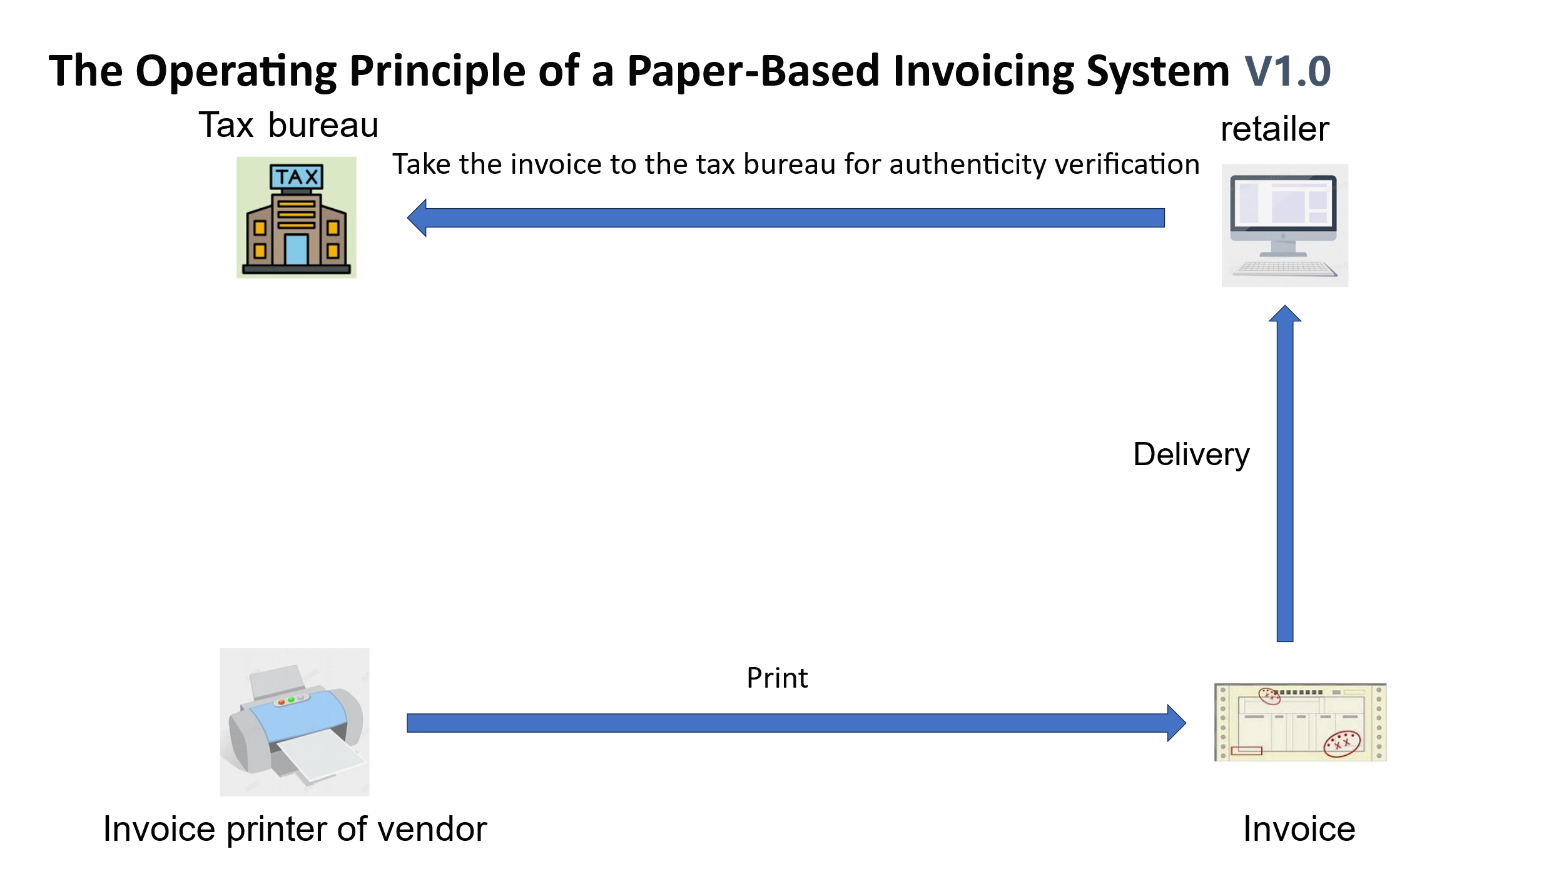

Figure 8

There is another type of paper invoice that combines information technology. As shown in Figure 9, the supplier first goes to the tax authority with an IC card to obtain invoice papers. The tax authority will input the anti-counterfeiting code into the IC card, and then the supplier returns to the company and writes the content of the IC card into the invoicing system. When the supplier sells goods and issues an invoice, the black box of the invoicing system will record the invoicing information. The information in the black box can only be read and cannot be modified. At the end of the month, the supplier needs to use the IC card to read out the invoicing data in the black box. At the beginning of the next month, the supplier connects the IC card to the invoicing system and makes a declaration through the network.

Compared with V1.0, the anti-counterfeiting property of the paper invoice in V2.0 has been improved, and the accuracy and efficiency of the tax authority in verifying the input tax information of the retailer have also been enhanced. This is because when the supplier connects to the network with the IC card for declaration, the tax authority can also obtain the input tax information of the retailer. However, this still cannot solve the problem of issuing a large number of false invoices in a short period of time. This is because whether it is the retailer or the supplier, as long as they are not connected to the network and do not use the IC card to read the data in the black box, the tax authority will not be able to obtain the invoicing information of enterprises or individuals in real time.

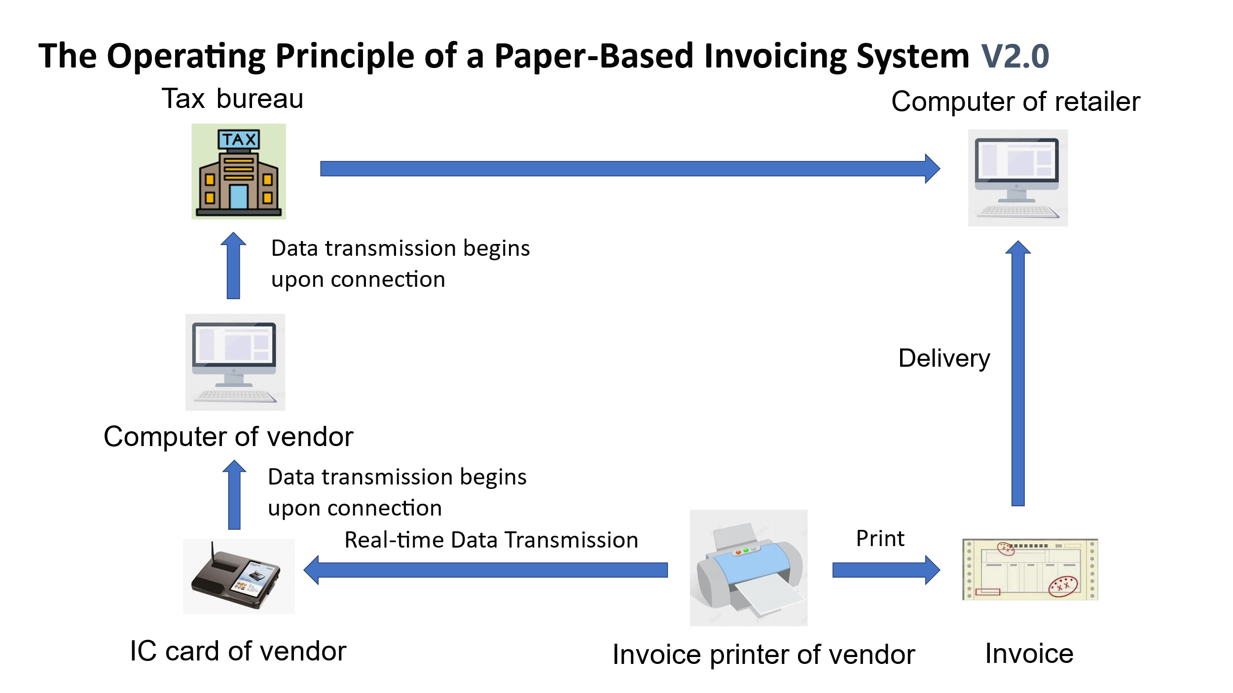

Figure 9

**2.** **Methods of Tax Evasion with Paper Invoices**

There are mainly the following types:：

I. Paper invoices serve as the original vouchers for accounting and are the basis for tax calculation. Some enterprises will reprint paper invoices and use them as expense vouchers, which is very useful for evading income tax.

II Some merchants will refuse to print invoices for consumers on the grounds that the printer is broken or that the invoice issuance limit for this month has been reached. Some consumers also do not ask for paper invoices after making a purchase. Merchants can take advantage of this situation to either not issue invoices or sell the invoices to other enterprises.

III. The IC card records the amount of paper invoices issued by an enterprise. Only after being connected to the network can the invoicing amount be uploaded to the tax authority through computer operations. Since the data is not uploaded in real time, there is more room for the illegal operation of issuing false invoices. Shell companies can issue a large number of false invoices within a short period, and the tax authority has no way of knowing.

IV. There are top-notch hackers who can modify the IC card. They can print out paper invoices while the IC card records no data at all. Or they can create huge input tax invoices out of thin air for themselves to reduce the tax amount.

**3. Anti-counterfeiting Principle of the Blockchain Electronic Invoice System**

Since its birth, blockchain technology has been known to everyone for its characteristics of distributed ledger and immutability. Blockchain was proposed by Satoshi Nakamoto in 2008 and was initially used for the construction and trading of Bitcoin. However, blockchain is not equal to Bitcoin. [6] Blockchain consists of a series of blocks, which are connected together through cryptographic hashes to form a continuous chain [7]. Each block contains a reference to the previous block, thus creating an ever-continuing blockchain [8]. Once data is recorded in the blockchain, it becomes extremely difficult to tamper with or delete [9]. This distributed ledger technology ensures that all participants in the network can access the complete transaction history. In a blockchain network, there is no central institution responsible for supervising the data. Instead, the data is shared among the servers in the network, which can be either private or public [10]. There are two types of blockchain networks: permissioned blockchains and permissionless blockchains. Permissioned blockchains restrict participants' access to transaction details and are only open to specific participants, while permissionless blockchains allow all network members to view all transaction details [8]. Blockchain technology provides security, trust, data integration, and anonymity without the need for third-party intermediaries [11].

Therefore, blockchain technology completely provides such a possibility that the electronic invoices generated by the invoicing system based on blockchain technology are all unique and immutable, and relevant users of the electronic invoice, such as suppliers, retailers, consumers, and tax authorities, can query the relevant information of the electronic invoice. Suppose the invoice has been used to deduct value-added tax, or as an expense to deduct corporate income tax, or has been taken by employees for corporate reimbursement. In that case, the status of this invoice will be updated and cannot be tampered with, and the behaviors of double-deducting the invoice and double-reimbursing the invoice will no longer exist.

In the research of Du Li and Zheng Yuwen, we may be able to deduce that the invoicing system of the Shenzhen Tax Bureau adopts a similar model. [12]. Milla Sepliana Setyowati and others mentioned that the traditional invoicing system is centralized. After a merchant issues an invoice, the consumer still needs to verify the received invoice. In contrast, the invoicing system designed based on blockchain technology can also eliminate the invoice verification process. [13] The tax system in Shenzhen has achieved this function, and consumers can directly reimburse the invoice without the invoice verification process. [14] Milla Sepliana Setyowati and others also mentioned that the smart contract technology of blockchain can ensure that taxpayers pay taxes to the national budget in real-time and automatically on the transaction day, thus significantly improving tax compliance and reducing the risk of tax evasion. Blockchain can not only avoid the risk of value-added tax evasion but also has the same effect on individual income tax for employees' salaries. During the salary transfer process, the payroll tax can be automatically captured and paid to the state treasury, thus eliminating the obligation of employers as tax collectors. [13] "A Blockchain-based Value Added Tax (VAT) System: Saudi Arabia as a Use-Case" by Ahmad Alkhodre and others explores a blockchain-based value-added tax collection system. The invoicing system of each company in the market is a node of the blockchain, which theoretically and technically proves the feasibility of making the value-added tax invoicing behavior transparent through blockchain. To collect value-added tax (VAT), the infrastructure of this system is built on the Hyperledger Fabric platform, integrating various entities in the field of supply chain management. The network consists of a server cluster, which includes order nodes, certificate authorities (CAs), and peer nodes. The value-added tax collection framework of Saudi Arabia is hosted on this cluster and is responsible for supervising and maintaining all logical components, including the establishment of the consensus mechanism and the operation of the certificate authorities [15]. Although their paper does not describe the details of the system in detail, it can be seen that they want to build a system where all companies can join as nodes. The flaw of the article is that they did not realize that the invoice is the most fundamental link in the collection of value-added tax, and they did not design the model based on the invoice.

In terms of technical details, many scholars have conducted research on algorithms. For example, "Blockchain-Based Decentralized Digital Content Management and Sharing System" by Thong Bui and others [16]. Although he introduced a sharing model for digital contracts, his sharing algorithm can be completely applied to electronic invoices to establish a sharing mechanism for invoice issuers and invoice holders. "Blockchain-Based System for Storing Warranty Receipts" by Shreerang Bhat and others describes a model of warranty receipts based on blockchain technology. The author's "warranty receipts" can be completely replaced with "invoices," so that his model and algorithm can be applied in a wider range [17]. Kean-Wah Cheng and Swee-Huay Heng introduced the sharing and storage mechanisms of the blockchain system in detail in "Blockchain-Based Content Sharing and Data Repository System," and the storage technologies and algorithms therein can also be applied to electronic invoices [18].

Finally, on Github, some people have actually open-sourced their developed invoice management systems or invoicing systems based on blockchain technology. Although the code is not mature enough to be applied on a large scale in reality, at least it allows us to know that such an invoicing system is completely feasible. As early as 2017, a netizen named rigelrozanski open-sourced the code of the invoicing system based on blockchain technology [19]. In addition, sriram-kakarala and others have also open-sourced relevant code [20]. By simply searching for the keywords "blockchain" and "invoice" on Github, a lot of open-source code can be found.

After confirming that the application of blockchain technology in the electronic invoicing system is technically feasible, it is also necessary to explore whether it is economically feasible. Whether this system can truly bring more revenue to the tax authority and whether it can bring benefits to the enterprises in the market, so that they are willing to accept this new system. Soohyun and others assumed two manufacturers and one retailer, where one of the two manufacturers will issue fewer invoices and the other will not. Through the game among the three parties, they determined the improvement of the system for their respective and overall interests. [21] However, the blockchain system described in this paper is different from the blockchain electronic invoice system explored in this thesis. The author did not describe the model of this system in detail, but it can be deduced that this system is a private chain system centered around the retailer, rather than the invoicing system of the tax authority.

**4.** **Technical Advantages of the Blockchain Electronic Invoice System**

There are mainly the following points:

I. The behavior of reprinting invoices will be completely eliminated. Because after an enterprise uses an invoice to deduct value-added tax and income tax, the corresponding status of the electronic invoice will be modified, and this status cannot be tampered with.

II. There is no limit on the amount of blockchain electronic invoices, nor is there any printing requirement. Merchants will issue electronic invoices for 100% of each sales transaction. The invoicing system is linked to the merchant's bank account. As long as the consumer makes a payment, the merchant's invoicing system will automatically issue an invoice.

III. The invoicing data is transmitted to the tax authority in real time. Therefore, the behavior of shell companies issuing a large number of false invoices within a short period of time will be stopped. This is because once the daily invoicing amount of these shell companies reaches a certain upper limit, it will be monitored by the tax authority.

IV. It is more difficult for hackers to attack the blockchain invoicing system than to hack an IC card. If a hacker wants to tamper with the invoicing data, the nodes they need to hack are not just one enterprise, but all the enterprises on the blockchain nodes.

**5．Comparison between the Paper Invoice System and the Blockchain Electronic Invoice System**

|  |  |  |
| --- | --- | --- |
|  | Paper Invoice System | Blockchain Electronic Invoice System |
| **Printing** | Requires a specialized printer and invoice paper for printing. | Does not require printing; the electronic version can serve as the original document for accounting and for inspection by audit bureaus and tax authorities. If printing is needed, any printer and paper can be used. |
| **Quota** | Tax authorities impose restrictions on the monthly quantity and amount of invoices a business can issue to control risks of fraudulent VAT invoices. Additional applications to the tax bureau are needed if the quota is exceeded. | Larger quotas are available, and applications can be made online at any time. |
| **Mailing** | Physical invoices need to be mailed between upstream and downstream enterprises for tax deduction purposes. | Invoices can be directly sent via digital tools such as email and WeChat without the need for mailing. |
| **Reimbursement** | Physical invoices are required for reimbursement, and there may be cases of duplicate reimbursement, especially when an enterprise's financial reimbursement process is not standardized—for example, photocopied paper invoices can still be used for reimbursement. | Only the electronic version is needed for reimbursement, which eliminates cases of duplicate reimbursement. At the same time, employees no longer need to worry about being unable to claim reimbursements due to lost paper invoices [25]. |
| **Duplicate Deduction of Income Tax** | The same invoice may be used by enterprises as an expense in different periods. By overstating expenses in this way, enterprises can reduce their income tax liability (e.g., the same invoice may be recorded as an expense for two different months or years). | Once declared, an invoice is stamped with a timestamp, making duplicate deductions easily detectable. |
| **Financial Efficiency** | Each financial document requires physical invoices to be bound and organized. | Only electronic documents need to be organized, which greatly facilitates audits by accounting firms. |
| **Timeliness** | Paper invoices are encrypted by tax control machines for anti-counterfeiting, but the invoicing data cannot be uploaded to the tax bureau in real time, leaving significant room for fraudulent VAT invoice issuance. | Invoicing data is uploaded to the tax bureau in real time. Large-scale fraudulent invoicing within a short period can be easily detected by the tax authority. |
| **Financial Risks** | Some enterprises create false accounting records for bank loans, inflating revenue through fake invoices to boost reported profits and secure more loans. | With blockchain technology, the authenticity of invoices can be easily verified, making invoice fraud extremely difficult. |
| **Communication Efficiency Between Enterprises** | During mailing, the invoice amounts between upstream and downstream enterprises often differ from previously agreed values, increasing communication costs. | Invoices can be sent in real time. If discrepancies in amounts are found, enterprises can communicate and resolve issues on the same day. |

Table 1

As can be seen from the above table, the blockchain electronic invoice system seems to be much more convenient than the paper invoice system. However, it is also necessary to consider whether the increased benefits brought by the blockchain electronic invoice and the costs invested by the tax authorities are reasonable. At the same time, on Zhihu, China's largest Q&A platform, many financial personnel are complaining that this system actually increases the workload and fails to improve the economic benefits of enterprises. [26]

In addition, the blockchain electronic invoice system has other deficiencies. Although China's blockchain electronic invoice system is already quite mature, there are still problems in the storage of electronic invoices. For example, consumers do not have a dedicated electronic invoice application, so they cannot centrally store all the invoices from their daily consumption in one application. One of the reasons is that local tax authorities have not yet launched relevant applications. Currently, invoices can only be stored in personal mailboxes or saved in mobile phones in the form of QR codes. The second reason is that the database systems of tax authorities in various regions have not yet achieved interconnection, while a unified national tax database is the future development trend. In fact, electronic invoices globally could also be based on the same blockchain platform, which would reduce the possibility of enterprises forging invoices of imported goods in international trade. K. Narayanam and others have proposed a global electronic transportation invoice system based on blockchain technology [27]. The relationship between enterprises and tax authorities remains a cat-and-mouse game. Although tax authorities may not be able to completely prevent business owners from evading taxes, this system has, to a certain extent, reduced the occurrence of tax evasion and ultimately enhanced economic benefits and social fairness.

**Methodology**

This thesis adopts the methods of literature research and computer simulation. The reason for using the computer simulation method is that it is very difficult to obtain tax evasion data. For example, we will never know how many enterprises in the market are evading taxes and what their tax evasion rates are. Some data are too sensitive, so the tax authorities choose not to disclose them. Even if they detect that an enterprise is evading taxes, they will also choose not to disclose it, because this will damage the reputation of the enterprise owner.

In addition, for other data, such as the amount of tax evasion in the market, how much the amount of tax evasion can be reduced by this system, and the cost of printing paper that can be saved by this system, etc., it is almost impossible to obtain them. Taking the amount of tax evasion as an example, few countries conduct research on relevant data. Take the United States as an example. According to the estimation of the U.S. Department of the Treasury, the "tax gap" (the difference between the tax owed and the tax collected) totals approximately 600 billion US dollars each year. [28] In 2023, the revenue from consumption tax in the United States accounted for 9.5% of the total tax revenue. [29] According to the data of the European Commission, EU countries lost €134 billion in VAT revenues in 2019. [30] Although the data are published on the official websites, they do not disclose how these data are statistically obtained, and these data cannot be used as empirical data in the model established in this thesis. Therefore, when simulating the data in this thesis, the theoretical data obtained through computer simulation will be used for analysis.

In the field of economic simulation, there are two methods, one is DSGE, and the other is ABM. DSGE (Dynamic Stochastic General Equilibrium model) is the mainstream framework in modern macroeconomics used to analyze economic cycles, policy shocks, and how to unify micro-foundations and macro-phenomena. In 1928, Frank P. Ramsey first established the dynamic general equilibrium framework of intertemporal optimization in "A Mathematical Theory of Saving" to study the optimal social savings rate [31]. In the 1960s and 1970s, economists such as Tjalling Koopmans and Lionel McKenzie formalized the dynamic optimization and general equilibrium theory [32][33]. In 1982, Finn E. Kydland and Edward C. Prescott, in the article "Time to Build and Aggregate Fluctuations", introduced technological shocks and the optimization method and proposed the Real Business Cycle (RBC) model, marking the official birth of the "Neoclassical Dynamic General Equilibrium" (i.e., DSGE) framework [34]. Clarida, Gali & Gertler (1999): On the basis of RBC, they introduced price and wage stickiness and the Calvo-Taylor rule, forming the embryonic form of the New Keynesian DSGE [32].

ABM (Agent-Based Modeling) is a computer simulation method that studies the macro-phenomena of complex systems by simulating the behaviors and interactions of autonomous decision-making individuals (Agents) in a specific environment. Joshua M. Epstein & Robert Axtell (1996) published "Growing Artificial Societies: Social Science From the Bottom Up", creating the large-scale economic-social ABM platform "Sugarscape" for the first time, and exploring macro-emergent phenomena such as wealth distribution, epidemics, and cultural diffusion [33]. Leigh Tesfatsion launched the special issue of Agent-Based Computational Economics (ACE) in 2001, standardizing the methods and standards of ABM in economics [34].

Compared with DSGE, ABM is more flexible, and its framework is not so fixed. It can define the individuals in economic activities from the most fundamental and microscopic level. Therefore, the computer simulation of this thesis will be based on the ABM method.

There are many ways to construct an ABM model. There is a relatively mature platform, Netlogo, and one can also build the model by oneself through programming in Java or Python. This article uses Python code to build the model for simulation by itself, and then stores the simulated data in Excel for data analysis. The analysis is carried out by using the data statistics function of Excel and Python programming analysis.

**Data Results and Analysis**

1. **Introduction of the Model**

When constructing the model using the ABM approach, the first thing to design is the agents and the market economic model. The agents designed in this model involve three roles: the tax bureau ($T$), farmers ($F_{i}$) and herdsmen ($H_{i}$) (𝑖∈𝑔, 𝑏, 𝑛). Among the farmers, there is a good person $F_{g}$, a bad person $F_{b}$, and a neutral person $F_{b}$. Among the herdsmen, there is a good person $H_{g}$, a bad person $H_{b}$, and a neutral person $H_{n}$. The initial asset $a_{i}^{j}$ $(j∈\left\{F, H\right\}$) of each of them is 100. In order to better study the economic changes under different conditions, the total amount of currency designed in this model is fixed, and there will be no phenomenon of currency outflow.

The model assumes that the daily demand of farmers is only meat, while the demand of herdsmen is only rice. One is protein and the other is carbohydrate, both of which are essential nutrients for the human body and belong to rigid demands. However, farmers can only produce rice and not meat, and herdsmen can only produce meat and not rice. Therefore, they have the motivation to trade with each other. The model also assumes that rice and meat are not completely homogeneous commodities, and they do not have a 100% substitution relationship. The main component of rice is carbohydrate, with a small amount of protein and fat. The main components of meat are protein and fat, with a small amount of carbohydrate. Therefore, they also have a certain complementary relationship. Moreover, the production of farmers and herdsmen is stable. As a result, the demand curves of these two types of commodities present the shape of a concave function.

Every day, farmers and herdsmen go to the market to buy the commodities they need. Each farmer sells a bowl of rice every day and buys a piece of meat from the herdsmen. The herdsmen sell a piece of meat every day and buy a bowl of rice from the farmers. However, sometimes farmers and herdsmen also sell two bowls of rice or two pieces of meat every day, with a probability of ${prob}^{m}$, which depends on the daily financial distribution of the tax bureau. The revenue $r$ of the tax bureau comes from tax revenue $t$ and fine revenue $f$. The tax bureau will evenly distribute the daily revenue to all farmers and herdsmen for them to carry out the construction and maintenance of public facilities, such as building roads, cleaning up fallen leaves, etc. In this thesis, building roads is taken as an example. The more funds the tax bureau allocates for road construction, the higher the enthusiasm of farmers and herdsmen for road maintenance, and the better the maintenance level of the roads. In this way, the probability that farmers and herdsmen transport two bowls of rice and two pieces of meat to the market every day will be higher, and finally the probability of making transactions twice a day will also be higher. Therefore, the revenue of the tax bureau is positively correlated with the probability of making transactions twice a day.

It is assumed that the probability of making transactions twice a day is ${prob}^{m}$, and the relationship between ${prob}^{m}$ and the revenue $r$ of the tax bureau is set as follows:

$${prob}^{m}=\frac{r}{6}$$

$$r=t+f$$

After arriving at the market, the good people, bad people, and neutral people among the farmers and herdsmen will randomly match for transactions. That is, a good person may conduct transactions with a good person, a neutral person, or a bad person, and the probability of each match is equal, which is 1/3. Their purchasing desires are the same, so the probability of a transaction being completed is also the same. The seller will randomly quote a price between 2.0, 2.1 and 5.0. The higher the price quoted by the seller, the lower the market demand. And because there is a certain complementary relationship as well as a certain substitution relationship between the rice produced by farmers and the meat produced by herdsmen, the model assumes that the demand curves of both rice and meat are concave functions. To a certain extent, the demand curve can reflect the buyer's purchasing desire, that is, the higher the price, the lower the purchasing desire, and thus the less the quantity demanded. Therefore, the model also assumes that there is a negative correlation between the price and the purchasing desire.

It is assumed that the quoted price is $p_{i}^{j}$, and the relationship between ${prob}^{b}$ and the quoted price $p_{i}^{j}$ is assumed as follows:

$${prob}^{b}=\frac{2.1}{{p_{i}^{j}}^{1.3}}$$

In order to increase the probability of a transaction, the bad people and the neutral people will sell at a reduced price. However, reducing the price will decrease their profits, so they will save costs by evading taxes. They will choose to underreport by 5%, and the tax rate is 10% of the original selling price. In this way, not only will the profit not be affected, but it will actually increase. Every day, there is an 80% probability, ${prob}_{b}^{e}$, that the bad people will evade taxes. At the same time, when quoting a price, they will underreport by 5% to increase the probability of a transaction. The neutral people have a 50% probability, ${prob}_{n}^{e}$, of evading taxes and will also underreport the price by 5%. The good people will never evade taxes, and they will pay taxes at a tax rate of $π^{t}$ = 10% of the daily transaction amount.

However, tax evasion also brings risks. If discovered by the tax bureau, the bad people and the neutral people will not only have to make up the unpaid taxes but also pay a fine equivalent to twice the amount of the evaded taxes. Every time they evade taxes, there is a probability of being discovered by the tax bureau, and the probability of being discovered is ${prob}_{t}$, which is also the success rate of the tax bureau's inspection.

After being discovered by the tax bureau for tax evasion, both the bad people and the neutral people will become timid and cautious. This period is called the cooling-off period $D_{i}$. The cooling-off period of the bad people, $D_{b}$ = 1, that is, the cooling-off period is one day. During this period, they will not evade taxes, but after the cooling-off period, their tax evasion rate will return to 80%. The neutral people have a cooling-off period of two days.

The farmers and herdsmen in the model only need to pay value-added tax and do not need to pay income tax. And in order to avoid the closed loop of the value-added tax chain and prevent the situation of zero value-added, the farmers and herdsmen will not be able to obtain input tax for the goods they purchase, but they need to pay output tax based on the sales amount when selling. Or this model can also be understood as only requiring the payment of consumption tax.

The following are the parameters used for computer simulation:

|  |  |  |
| --- | --- | --- |
| $$i$$ | $$g, b, n$$ | good people, bad people and neutral people |
| $$j$$ | $$F, H$$ | farmers, herdsmen |
| $$a_{i}^{j}$$ |  | asset |
| $${prob}^{m}$$ | $${prob}^{m}=\frac{r}{6}$$ | probability of a second transaction |
| $$r$$ | $$r=t+f$$ | daily income of the tax bureau |
| $$t$$ |  | daily tax revenue of the tax bureau |
| $$f$$ |  | daily fine revenue of the tax bureau |
| $$p_{i}^{j}$$ |  | price |
| $${prob}^{b}$$ | $${prob}^{b}=\frac{2.1}{{p_{i}^{j}}^{1.3}}$$ | probability of a deal being concluded |
| $${prob}_{i}^{e}$$ |  | probability of tax evasion |
| $$π^{t}$$ | $$π^{t}=10\%$$ | tax rate |
| $$π^{f}$$ | $$π^{f}=200\%$$ |  |
| $$c$$ | $$c=0.0, 0.3 0.6, 0.9$$ | cost of the invoice system |
| $${prob}_{c}^{t}$$ |  | success rate of tax inspection |
| $$D_{i}$$ | $D_{b}=1$, $D_{n}=2$ | cooling-off period |

Table 2

1. **Simulation of the Paper Invoice System**

In this simulation, pixel points of different colors will be used to represent different roles. Green represents the living places of farmers, red represents the living places of herdsmen, light blue represents good people, purple represents bad people, yellow represents neutral people, gray represents the market, and the blank area represents the roads. As shown in the following figure. 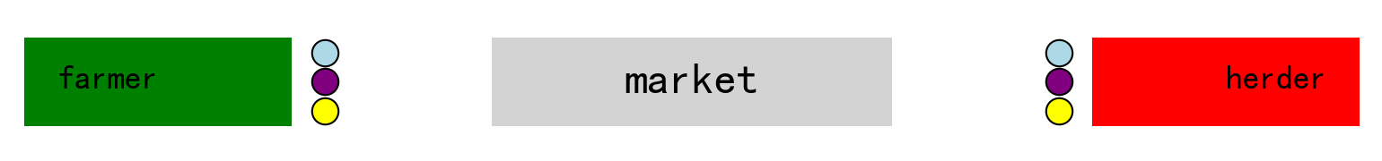

Figure 10

When the transaction starts, farmers and herdsmen will go to the market. The transaction adopts a random matching mechanism, and good people may trade with good people, bad people, and neutral people. After the transaction is completed, they will return to their original positions. Then, on the next day, the degree of road maintenance will be calculated according to the situation of fiscal expenditure. The better the road is repaired, the greater the probability that they will carry two bowls of rice or two pieces of meat to the market on that day, that is, the greater the possibility of making transactions twice.

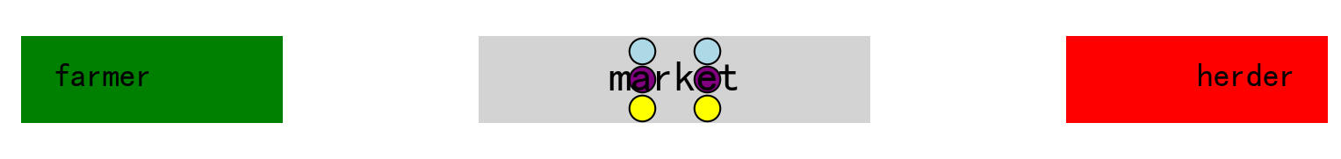

Figure 11

Based on the above model and parameters, this thesis will run a 200-day simulation on a computer, and this simulation will count the following data:

- The daily transaction amount of good people, bad people, and neutral people.

- The daily transaction volume of good people, bad people, and neutral people.

- The daily tax payment amount of good people, bad people, and neutral people.

- The daily change in assets of good people, bad people, and neutral people.

- The daily fine payment amount of good people, bad people, and neutral people.

- The probability of making transactions twice a day.

Since the success rate of inspection in the paper invoice system is uncertain, this simulation will assume that the success rates of inspection in the paper invoice system ${prob}_{0.0}^{t}$ are 0.2, 0.3, 0.4, 0.5, 0.6, 0.7, 0.8, and 0.9, and check the data results under different inspection success rates.

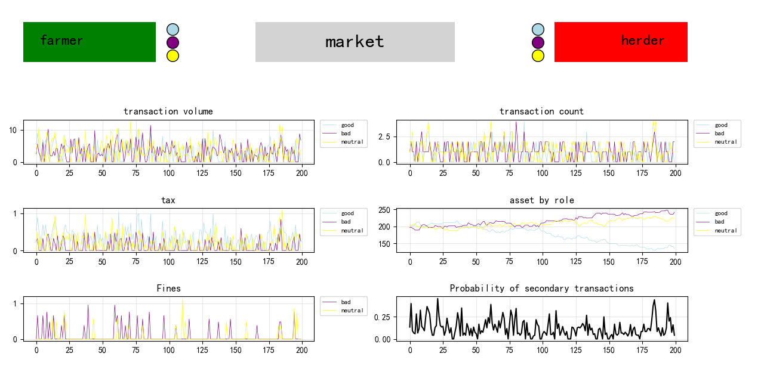

Figure 12

When ${prob}_{0.0}^{t}$ = 0.2, the simulation results are shown in Figure 12. According to the statistical chart, the fluctuation directions of the daily transaction amount, transaction volume, and tax revenue are the same. However, affected by the transaction price and the success rate of tax evasion, the magnitude of their rises and falls each time is not the same. In terms of assets, the assets of the bad people are ultimately the highest, followed by the neutral people, and finally the good people. It can be seen that within these 200 days, there was a period during which the assets of the good people and the neutral people were higher than those of the neutral people (it should be noted here that there may be a logical error in the original text as it is repeated, it might be intended to compare with the bad people), but they were overtaken close to the 200-day mark.

In terms of the magnitude of fluctuations, the transaction volume fluctuates between 0 and 15.1, the transaction count fluctuates between 0 and 4, the assets of good people, bad people, and neutral people fluctuate between 117.09 and 272.04, the tax payments fluctuate between 0 and 1.4, the fine payments fluctuate between 0 and 1.82, and the probability of secondary transactions fluctuates between 0 and 0.74.

In the case of a single simulation, the fluctuations of each data can be clearly seen, so as to analyze the relationships between each data. However, excessive fluctuations also bring problems. The results of each run may be very different, especially in asset statistics. The results of each simulation vary greatly, and there will be many possible results for the final asset rankings of good people, bad people, and neutral people, and any of them may come out on top.

In order to better analyze the data statistics under different inspection success rates ${prob}_{0.0}^{t}$ of the old and new systems, it is necessary for the simulation to eliminate the impact of excessive fluctuations. Therefore, in the subsequent analysis, the method of taking the average value after running multiple times will be adopted. All subsequent simulations will be run 3,000 times, and the data will be the average value after running 3,000 times. 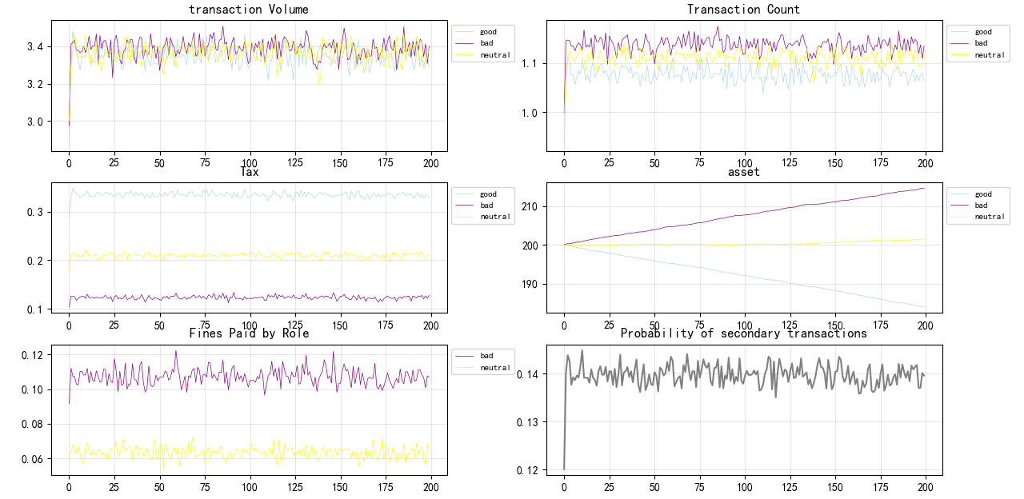

Figure 13

Figure 13 shows the results of taking the average after running 3,000 times. Compared with Figure 12, it can be seen that the value range of the vertical coordinates of all statistical data graphs has become smaller, and various curves are also much smoother. This means that the fluctuations of the data have decreased. If the number of simulation rounds is changed to more than 3,000, the results will obtain smoother curves with even smaller fluctuations. The total transaction volume stabilizes around 10, the transaction count is around 1.6. The assets of farmers and herdsmen fluctuate between 298 and 302. The changes in the assets of good people, bad people, and neutral people present the shape of smooth curves. Among them, the assets of bad people are continuously increasing, the assets of neutral people are growing slowly, and the assets of good people are constantly decreasing. Their final assets are 214.0, 201.5, and 184.5 respectively. In terms of the revenue of the tax bureau, the tax revenue stabilizes around 0.7, the fine revenue stabilizes around 0.17, and the probability of secondary transactions stabilizes around 0.14. The tax office revenue fluctuates between 0 and 2.2, and the probability of secondary transactions fluctuates between 0 and 0.6.

We can see from the chart the favorable impact of tax revenue on transactions. When the tax bureau uses the tax revenue for public expenditure (road construction), the probability that herdsmen and farmers transport two pieces of meat every day will increase. Therefore, the transaction amount will also rise, and the revenue of the tax bureau will increase as well. The amount used for fiscal expenditure will also increase, and finally a positive feedback is formed until the probability of secondary transactions reaches the maximum value and stabilizes around 1.4.

**2.1** **Data comparison under different inspection success rates**

In order to measure the impact of the invoice system on the economy, this article will conduct an analysis from two aspects. One is economic efficiency, and the other is the degree of social fairness. This article uses the revenue of the tax bureau and the total market trade volume to measure economic benefits. That is, the higher the revenue of the tax bureau and the market trade volume, the better the economic liquidity and the higher the economic benefits. As for social fairness, the proportion of the assets of good people on the last day will be used to measure the degree of social fairness. That is, the higher the proportion of the assets of good people, the fairer the whole society will be.

**2.1.1** **Economic benefits**

* + - 1. **Revenue of the Tax Bureau and the Probability of Secondary Transactions**

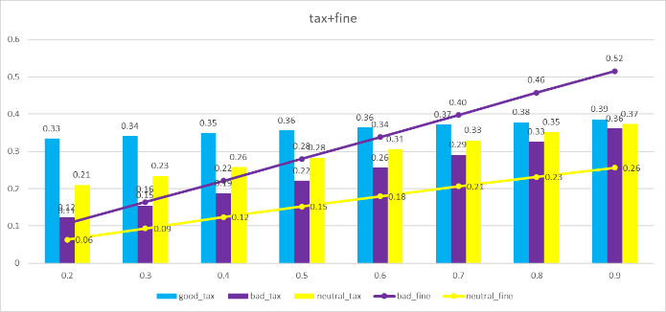

Figure 14

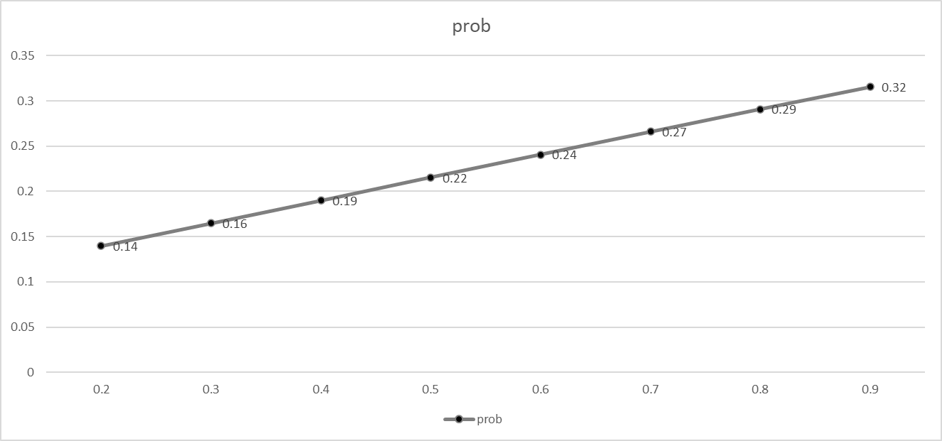

Figure 15

First, let's analyze the revenue situation of the tax bureau. It can be seen that as the inspection rate continues to increase, the taxes paid by good people, bad people, and neutral people are also continuously increasing, which means that the total tax revenue of the tax bureau is also rising. At the same time, the fines paid by neutral people and bad people are also increasing continuously, so the fine revenue of the tax bureau is also rising. After the total revenue of the tax bureau increases, the probability of secondary transactions will also continue to increase.

In terms of tax revenue, the tax payments of bad people and neutral people have increased significantly compared with those of good people. In addition to the increased probability of secondary transactions, the probability of them being inspected has also increased. As a result, not only has their success rate of tax evasion decreased, but the number of times they are in the cooling-off period has also increased. During the cooling-off period, they cannot evade taxes and can only pay taxes.

In terms of fine revenue, when the inspection rate exceeds 0.3, the amount of fines paid by bad people exceeds the amount of taxes they pay. When it exceeds 0.4, the total amount of taxes and fines paid by bad people and neutral people exceeds that of good people. This means that they have changed from beneficiaries of social public resources to contributors. **2.1.1.2 Transaction volume**

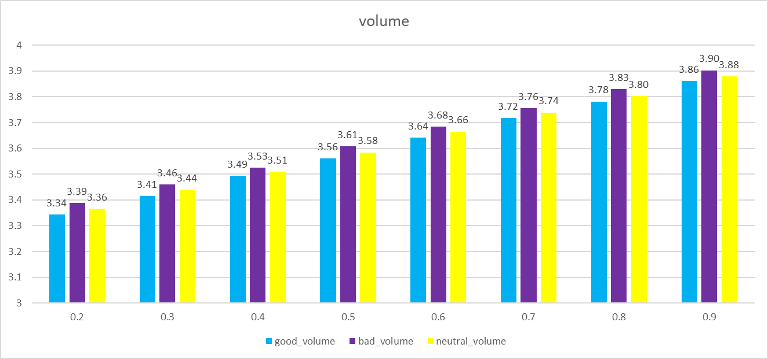

Figure 16

It can be seen that under different inspection success rates ${prob}_{0.0}^{t}$, the sales volume of bad people is always the highest. This is because bad people offer a 50% discount on each sale, which can increase the success rate of the transaction. Next comes the neutral people, and finally the good people. At the same time, we can also observe that as the inspection success rate increases, the sales volumes of all three groups are also rising. This is because the higher the inspection success rate, the higher the tax revenue and fine revenue of the tax bureau, and the more funds are available for public expenditure. As a result, the probability that farmers and herdsmen can make sales twice a day is higher. Therefore, as the inspection rate increases, the economic benefits have all improved.

* + - 1. **Quantity of transactions**

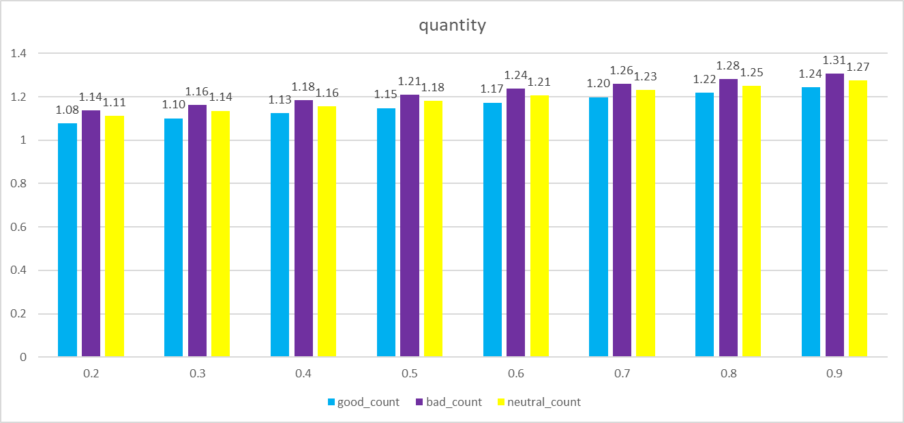

Figure 17

The daily quantity of transactions also increases as the inspection success rate rises. Moreover, the bad guys have the highest quantity of transactions, followed by the neutral people, and finally the good guys.

* + - 1. **Degree of fairness**
      2. **Asset**

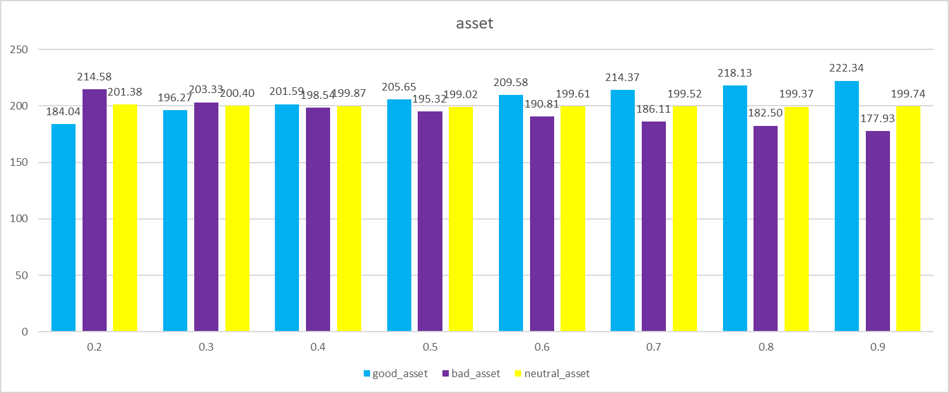

Figure 18

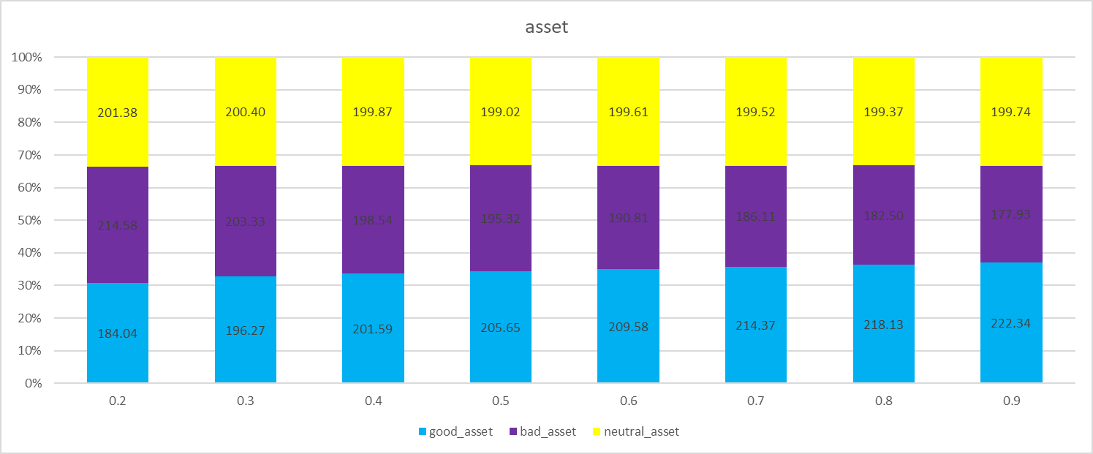

Figure 19

In terms of assets, as the inspection rate increases, the assets of good people continue to rise, while those of bad people keep declining. Neutral people are less affected by the inspection rate. Good people can get better rewards when they comply with tax laws, and social fairness has been improved.

**3.** **Simulation of the Blockchain Electronic Invoice System**

The above simulation is the data statistical results of the paper invoice system under different inspection success rates. However, the cost of the blockchain electronic invoice system cannot be the same as that of the paper invoice. On the contrary, there is a high probability that the cost of the blockchain electronic invoice system is higher than that of the paper invoice. Therefore, for the blockchain electronic invoice, we will make the following assumptions:

I. The cost of the blockchain electronic invoice system is c, while the cost of the paper invoice system is so low compared with the daily revenue of the tax bureau that it can be ignored, that is, it is 0. In the model, we will calculate and simulate the data statistical situations when the cost of the blockchain electronic invoice system is 0.3, 0.6, and 0.9, and make a comparison with the data of the paper invoice.

II. Regarding the tax revenue and fine revenue, the tax bureau will first use them to maintain the system cost c. The maintenance of the system cost is defined in the model as the salary paid to IT personnel, and the daily expenses of these IT personnel are to buy rice and meat in the market. Therefore, the salary of IT personnel will eventually flow back to the farmers and herdsmen. Of course, the actual system cost is definitely not just as simple as the salary of IT personnel. There are also server fees paid to suppliers, patent fees, water and electricity fees, etc. However, the ultimately paid costs will all flow back to the food market because food is a necessity. And in order to simplify the model and make the process clearer, the model assumes that the money spent on road construction and IT by the tax bureau will be evenly distributed back to the farmers and herdsmen.

III. The relationship between the probability of secondary transactions ${prob}^{m}$ and the fiscal expenditure is as follows:

$${prob}^{m}=\frac{r-c}{6}$$

For the paper invoice system, $c=0$。

**3.1.** **Economic benefits**

**3.1.1.Probability of secondary transactions**

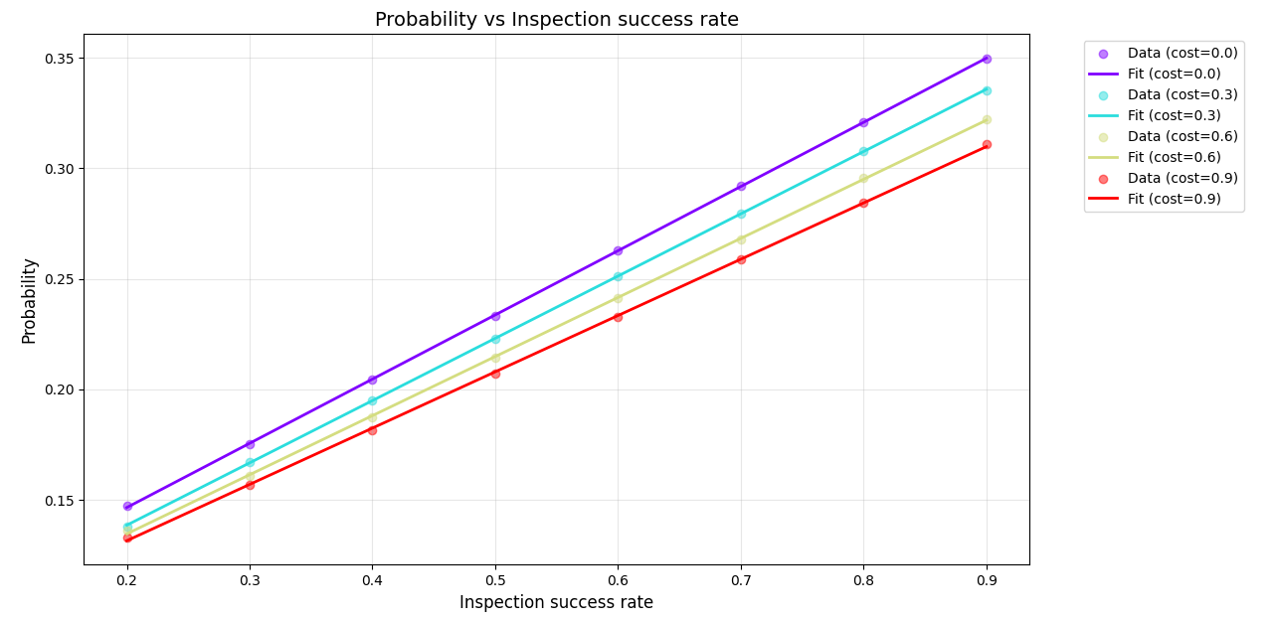

Figure 20

The above figure shows the probability of secondary transactions of invoice systems with different costs under different inspection rates. From the figure, it can be seen that regardless of the cost, the relationship between the inspection rate and the probability of secondary transactions is positively correlated and approaches a straight line. Therefore, it can be assumed that their relationship is a linear function. Through regression fitting, their equation is obtained as:

**When c = 0.0:**

${prob}^{m}$ = 0.088522 + 0.290376 ${prob}_{0.0}^{t}$

*

R² = 0.999962

**When c = 0.3:**

${prob}^{m}$ = 0.082279 + 0.281677 ${prob}_{0.3}^{t}$

*

R² = 0.999975

**When c = 0.6:**

${prob}^{m}$ = 0.081229 + 0.267295 ${prob}_{0.6}^{t}$

*

R² = 0.999859

**When c = 0.9:**

${prob}^{m}$ = 0.080654 + 0.254638 ${prob}_{0.9}^{t}$

*

R² = 0.999814

Whether it is from the graph or the finally fitted function, it can be seen that the slope of the paper invoice system is the highest, while the slope of the blockchain electronic invoice system with c = 0.9 is the lowest. This means that for the paper invoice system, increasing the inspection rate can lead to a higher probability of secondary transactions, that is, the marginal benefit is higher.

**3.1.2.Revenue**

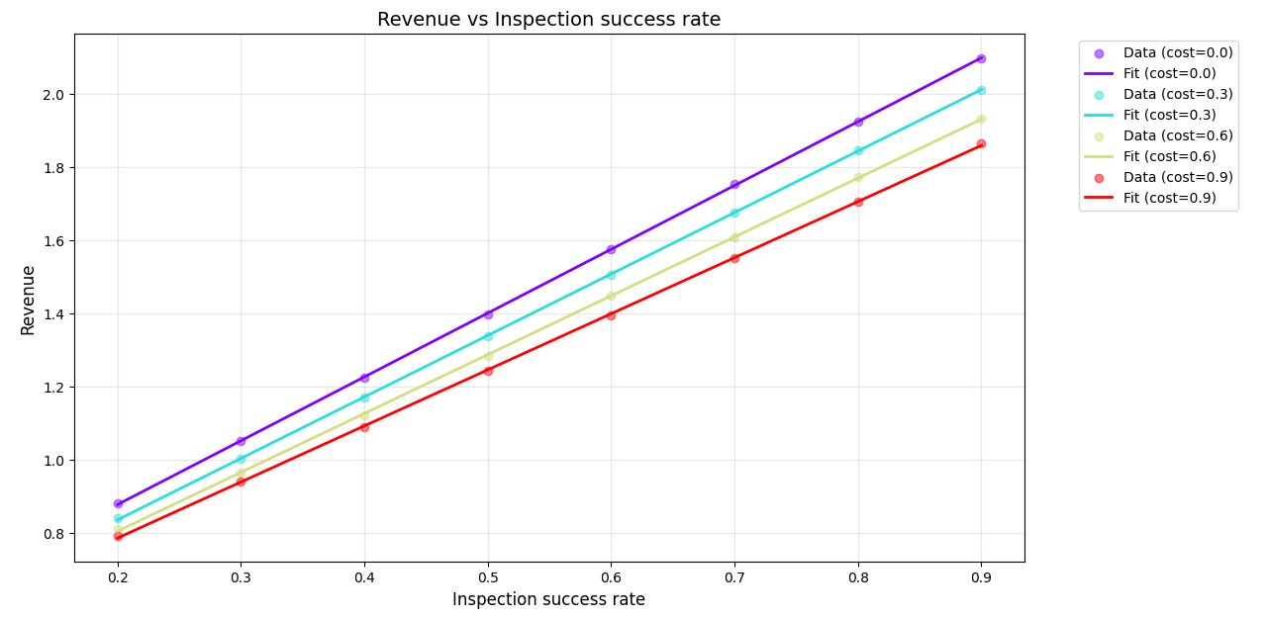

Figure 21

Similarly, by performing a regression of a linear equation for ${prob}_{c}^{t}$ and revenue, we obtain:

**When c = 0.0:**

revenue = 0.529706 + 1.744297 ${prob}_{0.0}^{t}$

*

R² = 0.999

**When c = 0.3:**

revenue = 0.500779 + 1.679909 ${prob}_{0.3}^{t}$

*

R² = 0.999

**When c = 0.6:**

revenue = 0.484021 + 1.608560 ${prob}_{0.6}^{t}$

*

R² = 0.999

**When c = 0.9:**

revenue = 0.480394 + 1.532866 ${prob}_{0.9}^{t}$

*

R² = 0.999

Similar to the probability of secondary transactions, the total revenue of the tax bureau is the highest when the cost of the invoice system c = 0, and the marginal benefit under different inspection rates is also the highest.

Next, let's study under what costs and inspection rates of the blockchain electronic invoice system the tax bureau can obtain more revenue than from the paper invoice system. We can first assume that the revenues are equal when c = 0 and c = 0.3, that is,

0.529706 + 1.744297 ${prob}_{0.0}^{t}$* = 0.500779 + 1.679909 ${prob}_{0.3}^{t}$

*

By solving the equation, we get:

$${prob}_{0.3}^{t}=1.0383{prob}_{0.0}^{t}+0.0289$$

That is to say, when the cost of the blockchain electronic invoice system c = 0.3, the inspection success rate of this system needs to satisfy ${prob}_{0.3}^{t}>1.0383{prob}_{0.0}^{t}+0.0289$ for this new system to bring more revenue to the tax bureau.

Similarly, we can obtain:

$${prob}_{0.6}^{t}=1.0844{prob}_{0.0}^{t}+0.0457$$

$${prob}_{0.9}^{t}=1.1379{prob}_{0.0}^{t}+0.0493$$

That is to say, when the cost of the blockchain electronic invoice system is 0.6, the inspection success rate of the system needs to satisfy ${prob}_{0.6}^{t}>1.0844{prob}_{0.0}^{t}+0.0457$ for the new system to bring more revenue to the tax bureau. When the cost of the blockchain electronic invoice system is 0.9, the inspection success rate of the system needs to satisfy ${prob}_{0.9}^{t}>1.1379{prob}_{0.0}^{t}+0.0493$ for the new system to bring more revenue to the tax bureau.

**3.1.3.Volume**

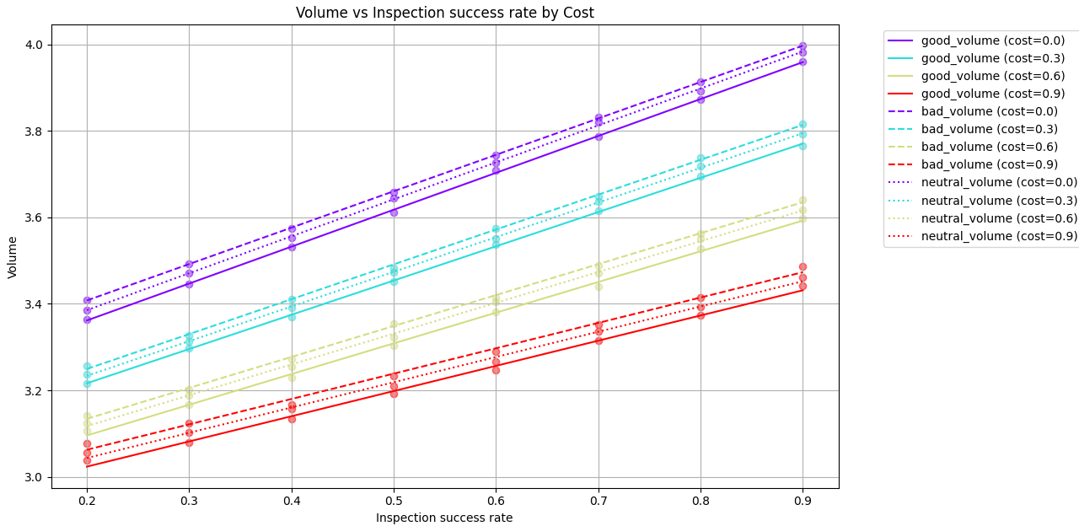

Figure 22

Through the fitting of the regression equation, the following results are obtained:

**good_volume ：**

**When c = 0.0:**

good_volume = 3.191 + 0.853 ${prob}_{0.0}^{t}$

*

R² = 1.000

**When c = 0.3:**

good_volume = 3.058 + 0.792 ${prob}_{0.3}^{t}$

*

R² = 1.000

**When c = 0.6:**

good_volume = 2.954 + 0.710 ${prob}_{0.6}^{t}$

*

R² = 0.998

**When c = 0.9:**

good_volume = 2.907 + 0.582 ${prob}_{0.9}^{t}$

*

R² = 0.996

**bad_volume：**

**When c = 0.0:**

bad_volume = 3.239 + 0.842 ${prob}_{0.0}^{t}$

*

R² = 1.000

**When c = 0.3:**

bad_volume = 3.088 + 0.806 ${prob}_{0.3}^{t}$

*

R² = 0.999

**When c = 0.6:**

bad_volume = 2.991 + 0.715 ${prob}_{0.6}^{t}$

*

R² = 0.999

**When c = 0.9:**

bad_volume = 2.945 + 0.586 ${prob}_{0.9}^{t}$

*

R² = 0.995

**neutral_volume：**

**When c = 0.0:**

neutral_volume = 3.214 + 0.854 ${prob}_{0.0}^{t}$

*

R² = 1.000

**When c = 0.3:**

neutral_volume = 3.073 + 0.801 ${prob}_{0.3}^{t}$

*

R² = 1.000

**When c = 0.6:**

neutral_volume = 2.975 + 0.712 ${prob}_{0.6}^{t}$

*

R² = 0.999

**When c = 0.9:**

neutral_volume = 2.927 + 0.584 ${prob}_{0.9}^{t}$

*

R² = 0.997

For the convenience of analysis, we use the total quantity of transactions to measure the total economic benefits of this economy, and examine what conditions the inspection rate of the blockchain electronic invoice system with different costs needs to meet in order to bring higher economic benefits than the paper invoice system.

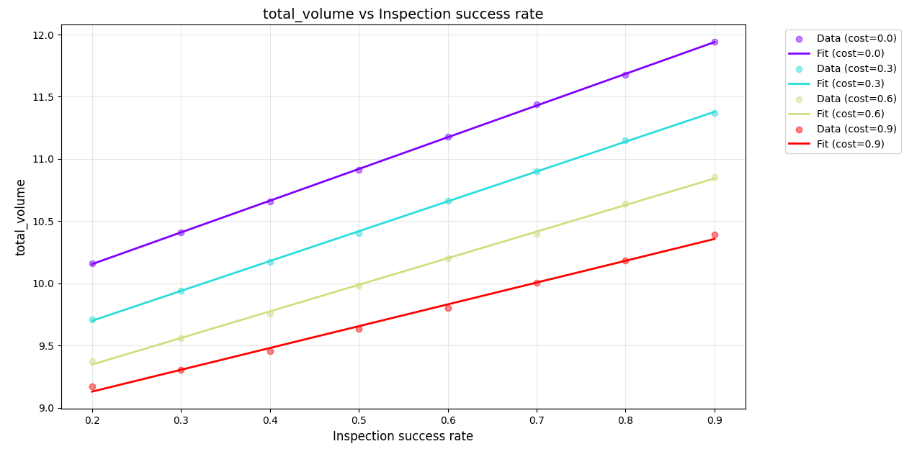

Figure 23

**When c = 0.0:**

volume = 9.644755 + 2.549258 ${prob}_{0.0}^{t}$

*

R² = 0.999

**When c = 0.3:**

volume = 9.219388 + 2.399206 ${prob}_{0.3}^{t}$

*

R² = 0.999

**When c = 0.6:**

volume = 8.919576 + 2.137473 ${prob}_{0.6}^{t}$

*

R² = 0.999

**When c = 0.9:**

volume = 8.779093 + 1.752870 ${prob}_{0.9}^{t}$

*

R² = 0.996

When c = 0.3, assume that:

9.644755 + 2.549258 ${prob}_{0.0}^{t}$* = 9.219388 + 2.399206 ${prob}_{0.3}^{t}$

*

It is solved that:

${prob}_{0.3}^{t}$ =1.0625 ${prob}_{0.0}^{t}$ +0.4254

So when c = 0.3, the inspection success rate needs to be more than 1.0625 times that of the paper invoice system's inspection success rate and also 0.4254 higher in order for the economic benefits to be significantly improved.

Similarly, we can get:

${prob}_{0.6}^{t}$ =1.1927 ${prob}_{0.0}^{t}$ +0.7252

${prob}_{0.9}^{t}$ =1.4544 ${prob}_{0.0}^{t}$ +0.8657

So when c = 0.6, the economic benefits can be significantly improved only when the inspection success rate is more than 1.1927 times that of the paper invoice system's inspection success rate and also 1.0813 higher. When c = 0.9, the economic benefits can be significantly improved only when the inspection success rate is more than 1.1927 times that of the paper invoice system's inspection success rate and also 1.0813 higher.

**3.2.** **Degree of fairness**

**3.2.1.Asset**

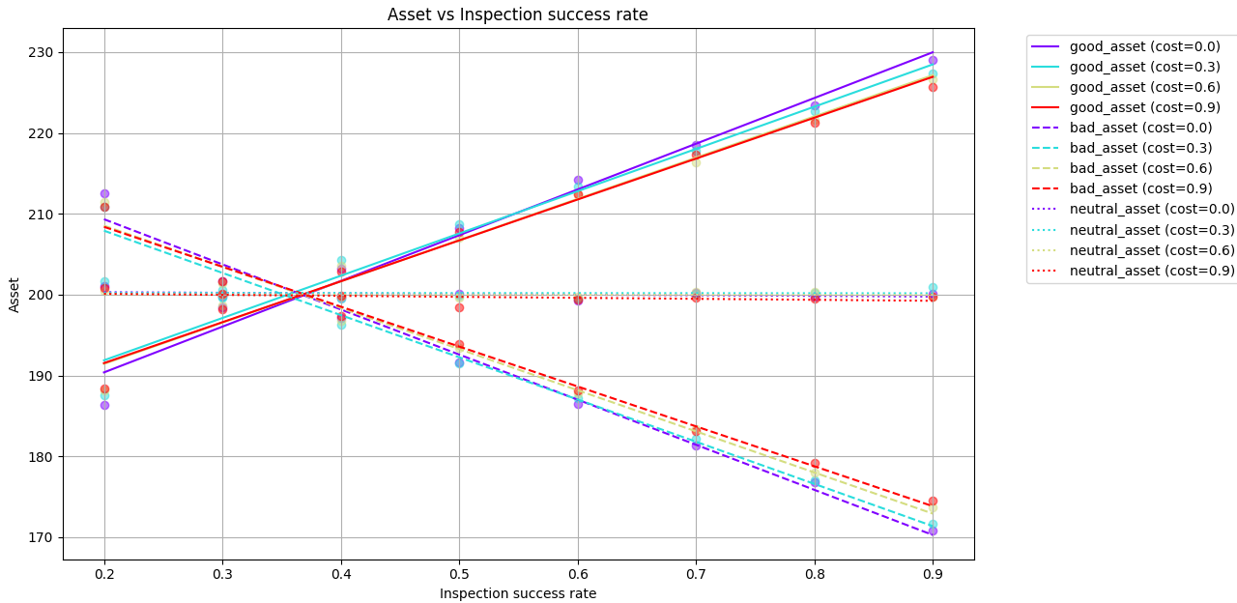

Figure 24

Fit the regression equation for the asset curves of good people and bad people. **good_asset：**

**When c = 0.0:**

good_asset = 179.063 + 56.567 ${prob}_{0.0}^{t}$

*

R² = 0.979

**When c = 0.3:**

good_asset = 181.418 + 52.281 ${prob}_{0.3}^{t}$

*

R² = 0.972

**When c = 0.6:**

good_asset = 181.228 + 51.014 ${prob}_{0.6}^{t}$

*

R² = 0.982

**When c = 0.9:**

good_asset = 181.406 + 50.588 ${prob}_{0.9}^{t}$

*

R² = 0.984

**bad_asset：**

**When c = 0.0:**

bad_asset = 220.480 - 55.788 ${prob}_{0.0}^{t}$

*

R² = 0.986

**When c = 0.3:**

bad_asset = 218.346 - 52.200 ${prob}_{0.3}^{t}$

*

R² = 0.987

**When c = 0.6:**

bad_asset = 218.709 - 50.889 ${prob}_{0.6}^{t}$

*

R² = 0.986

**When c = 0.9:**

bad_asset = 218.257 + -49.362 ${prob}_{0.9}^{t}$

*

R² = 0.989

It can be seen that regardless of the cost, when the inspection rate is greater than 0.4, the assets of good people will be higher than those of bad people and neutral people.

At the same time, it can also be seen that when the inspection rate is relatively small, close to 0.2, the assets of good people under the paper invoice system are lower than those under the blockchain electronic invoice system. When the inspection rate increases and exceeds 0.4, the assets of good people under the paper invoice system are higher than those under the blockchain electronic invoice system. For bad people, when the inspection rate is relatively small, the assets of bad people under the paper invoice system are lower than those under the blockchain invoice system. When the inspection rate is greater than 0.4, the assets of bad people under the paper invoice system are lower than those under the blockchain electronic invoice system. And when it is near 0.4, when the cost c = 0.3, the assets of good people are the highest, that is, the degree of social fairness is the highest.

**Conclusion**

Due to certain reasons, the data analysis in this thesis did not use real data for analysis. Instead, it adopted the methods of modeling and computer simulation. However, this data simulation still provided us with highly valuable scientific research achievements. Firstly, this model well simulates the economic and trade situation when the total amount of real currency is fixed. Secondly, the model has a great number of customizable parameters, such as the tax rate, penalty rate, formula for the desire to purchase, formula for the probability of secondary transactions, and the cost of the tax system, etc.

In addition, this model is not limited to the comparison of the economic values between the blockchain electronic invoice system and the paper invoice system. It can also be used to analyze any invoice system, such as the comparison between the paper invoice system and the centralized electronic invoice system. It can be further expanded. For example, more goods and services can be designed according to Maslow's hierarchy of needs curve, more roles and commodity circulation links can be added, and items like the input tax of value-added tax and income tax can be taken into consideration, and so on. The code of this model has also been open-sourced on GitHub. Therefore, tax bureaus of various countries can conduct secondary modeling based on this model and carry out simulation predictions by combining with their own data. This is of great value not only to tax bureaus but also to human economic activities.

The simulation results in this thesis also provide us with an answer: compared with the paper invoice system, under certain costs, if the inspection rate of the blockchain electronic invoice system can be reasonably increased, both economic efficiency and social fairness can be improved. This also proves the economic feasibility of implementing this system.

**Bibliography**

1. Lauré, M. (1954). Le système de taxe sur la valeur ajoutée (TVA). Revue Française de Finances Publiques, 8(2), 145-158.

1. [2023年财政收支情况_部门动态_中国政府网](https://www.gov.cn/lianbo/bumen/202402/content_6929621.htm)
2. [经济日报：深圳开出区块链电子发票近千万张](https://shenzhen.chinatax.gov.cn/sztax/zdgkml/xwfb/mtbd/201911/0cf9e920d4fe40afb11e95d20f04dee2.shtml)
3. 魏庆福. 增值税防伪税控系统及其安全性设计[J]. 中国工程科学,2000,2(11):84-87. DOI:10.3969/j.issn.1009-1742.2000.11.013.
4. [增值税防伪税控系统的原理是什么_税务网校-正保会计网校](https://www.chinaacc.com/new/253/257/283/2006/1/ad78982273517160023146.htm)
5. Nakamoto, S. (2008). Bitcoin: A Peer-to-Peer Electronic Cash System. Retrieved from <https://bitcoin.org/bitcoin.pdf>
6. Gupta, M. Blockchain for Dummies, IBM Limited ed.; John Wiley & Sons, Inc.: Hoboken, NJ, USA, 2017.
7. Bambara, J.J.; Allen, P.R. Blockchain: A Practical Guide to Developing Business, Law, and Technology Solutions; McGraw-Hill Education: New York, NY, USA, 2018.
8. Laurence, T. Blockchain for Dummies; John Wiley & Sons, Inc.: Hoboken, NJ, USA, 2017.
9. Schenk, A. Value Added Tax a Model Statute and Commentary; American Bar Association: Chicago,IL,USA,1989.
10. Janssen, M.; Weerakkody, V.; Ismagilova, E.; Sivarajah, U.; Irani, Z. A framework for analysing blockchain technology adoption: Integrating institutional, market and technical factors. Int. J. Inf. Manag. 2019, 50, 302–309. [CrossRef]
11. 杜莉,郑毓文.应用区块链技术推动我国增值税征管创新:机制分析和方案设计[J].税务研究,2018,0(6):72-79
12. Milla Sepliana Setyowati, Niken sila De Utami, Arfah Habib Saragih, Adang Hendrawan,Blockchain Technology Application for Value-Added Tax Systems,Journal of Open Innovation: Technology, Market, and Complexity,Volume 6, Issue 4,2020,156,ISSN 2199-8531,https://doi.org/10.3390/joitmc6040156.
13. [深圳商报：您被“区块链电子发票”改变了吗？](https://shenzhen.chinatax.gov.cn/sztax/xwdt/mtsd/201908/fc601d7dbd4649419d37d3e400f5b3b8.shtml)
14. Ahmad Alkhodre, Toqeer Ali, Salman Jan, Yazed Alsaawy, Shah Khusro and Muhammad Yasar, “A Blockchain-based Value Added Tax (VAT) System: Saudi Arabia as a Use-Case” International Journal of Advanced Computer Science and Applications(IJACSA), 10(5), 2019. [http://dx.doi.org/10.14569/IJACSA.2019.0100588](https://dx.doi.org/10.14569/IJACSA.2019.0100588)
15. Bui, Thong & Tan, Le & Nguyen, Tri-Hai & Trawinski, Bogdan & Nguyen, Huy-Tien & Le, Tung. (2022). Blockchain-Based Decentralized Digital Content Management and Sharing System. 10.1007/978-3-031-21967-2_49.
16. Bhat, S., Mehta, P., Marathe, M. (2023). Blockchain-Based System for Storing Warranty Receipts. In: Ranganathan, G., Fernando, X., Rocha, Á. (eds) Inventive Communication and Computational Technologies. Lecture Notes in Networks and Systems, vol 383. Springer, Singapore. https://doi.org/10.1007/978-981-19-4960-9_27
17. Cheng, KW., Heng, SH. (2021). Blockchain-Based Content Sharing and Data Repository System. In: Anbar, M., Abdullah, N., Manickam, S. (eds) Advances in Cyber Security. ACeS 2020. Communications in Computer and Information Science, vol 1347. Springer, Singapore. <https://doi.org/10.1007/978-981-33-6835-4_14>
18. <https://github.com/rigelrozanski/trackomatron.git>
19. https://github.com/sriram-kakarala/ChaInVoice.git
20. Soohyun Cho, Kyungha (Kari) Lee, Arion Cheong, Won Gyun No & Miklos A. Vasarhelyi (2021) Chain of Values: Examining the Economic Impacts of Blockchain on the Value-Added Tax System, Journal of Management Information Systems, 38:2, 288-313, DOI: 10.1080/07421222.2021.1912912
21. D. Xiaoping, L. Tao and D. Xiaoyuan, "Research on the intelligent settlement cloud platform of electric power materials based on the electronization of blockchain VAT special invoice," 2021 China International Conference on Electricity Distribution (CICED), Shanghai, China, 2021, pp. 948-952, doi: 10.1109/CICED50259.2021.9556752. keywords: {Cloud computing;Finance;Materials reliability;Market research;Real-time systems;Blockchains;Power systems;VAT special electronic invoice;blockchain;Cloud computing;Internet thinking;Invoice automatic generation;Reliable transmission and digital archiving;Intelligent settlement},
22. [(42 封私信 / 4 条消息) 为啥要兴个电子发票出来? - 知乎](https://www.zhihu.com/question/509805193)
23. K. Narayanam et al., "Blockchain Based e-Invoicing Platform for Global Trade," 2020 IEEE International Conference on Blockchain (Blockchain), Rhodes, Greece, 2020, pp. 385-392, doi: 10.1109/Blockchain50366.2020.00056.
24. Ramsey, F. P. (1928). A mathematical theory of saving. *Economic Journal*, *38*(152), 543–559
25. Tjalling C. Koopmans (1963)，“On the Concept of Optimal Economic Growth” (Cowles Discussion Paper No. 163)
26. Lionel W. McKenzie (1976)，“Turnpike Theory”，《Econometrica》44(5): 841–865
27. [The Case for a Robust Attack on the Tax Gap | U.S. Department of the Treasury](https://home.treasury.gov/news/featured-stories/the-case-for-a-robust-attack-on-the-tax-gap)
28. [US Tax Revenue by Tax Type, 2024 Update | Tax Foundation](https://taxfoundation.org/data/all/federal/us-tax-revenue-by-tax-type-2024/)
29. [VAT Gap: EU countries lost €134 billion in VAT revenues in 2019 - European Commission](https://taxation-customs.ec.europa.eu/news/vat-gap-eu-countries-lost-eu134-billion-vat-revenues-2019-2021-12-02_en)
30. Kydland, F. E., & Prescott, E. C. (1982). *Time to Build and Aggregate Fluctuations*. Econometrica, 50(6), 1345–1370.
31. Clarida, R., Gali, J., & Gertler, M. (1999). *The Science of Monetary Policy: A New Keynesian Perspective*. Journal of Economic Literature, 37(4), 1661–1707.
32. Epstein, J.M., & Axtell, R. (1996). *Growing Artificial Societies: Social Science From the Bottom Up*. Brookings Institution Press / MIT Press.
33. Tesfatsion, L. (2001). Introduction to the special issue on agent-based computational economics. *Journal of Economic Dynamics & Control*, 25(3–4), 281–293.

**Appendices**

One time simulation_en.py: This is the code for a single simulation with an animation. The parameters inside include initial assets, cost, inspection rate, tax rate, etc. You can modify the corresponding parameters to simulate different scenarios.

3000 time simulation_en.py: This is the code for conducting 3000 simulations and taking the average. The final output documents of this code include an Excel file and a PNG image, which record the data changes within 200 days, including farmers' assets, transaction volume, tax bureau's revenue, probability of secondary transactions, etc.

Modify_en.py: This is the code used to adjust the arrangement order of the exported Excel. It moves "meat" to the first column and "rice" to the second column. The purpose is to make the header order of the Excel files generated under different costs and inspection rates consistent.

Data and chart.xlsx: This is an Excel file used to generate line charts and bar charts for the paper invoice system.

Compare.xlsx: This is the code used to compare the paper invoice system and the blockchain electronic invoice system.

Regression_prob.py, regression_volume.py, etc.: These are used to obtain the regression equations and statistical graphs for various types of data.

Operation instructions and simulation process:

1. Open and run one time simulation_en.py. You can intuitively view the simulation animation and real - time data changes.

2. Create different folders: 0.0cost, 0.3cost, 0.6cost, 0.9cost, which are used to save the statistical graphs and Excel data files generated by different simulations respectively. Copy 3000 time simulation_en.py to different folders and modify the cost parameter "c" in the corresponding code to c = 0, c = 0.3, c = 0.6, c = 0.9 respectively.

3. Open 3000 time simulation_en.py in the 0.0cost folder. Change the inspection rate to 0.2. After running, two files named 0.0cost_simulation_results0.2.png and 0.0cost_simulation_results0.2.xlsx will be generated. Here, 0.0 represents the cost and 0.2 represents the inspection success rate. Then change the inspection rate in the code to 0.3 and run the code again to generate the files. The operations in other folders are the same.

4. After generating all the files with inspection success rates from 0.2 to 0.9, run modify_en.py to adjust the file format.

5. Copy and paste data and chart.xlsx into all the folders.

6. Select all the data from 0.0cost_simulation_results0.2.xlsx to 0.0cost_simulation_results0.9.xlsx and copy - paste them into the sheets named 0.2 to 0.9 in data and chart.xlsx respectively. Then the statistical graphs and line charts will be automatically generated.

7. Create a new folder named "compare". Put compare.xlsx into this folder. Then copy and paste the data from the sheet named "average" in data and chart.xlsx of different folders into the sheet named "data" in compare.xlsx.

8. Run regression_prob.py and regression_volume.py to obtain different statistical graphs and regression equations.